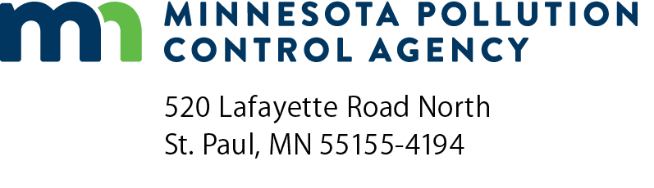 | Notification of Compliance Status Form  National Emission Standard for Hazardous Air Pollutants (NESHAP)  Dry Cleaning  Doc Type: Notifications

A notification of compliance status is required by 40 CFR § 63.324(b). This notification must be submitted on or before 30 days after startup.
Send a signed and scanned PDF copy of this form to: | AQRoutineReport.PCA@state.mn.us
 | and
 | EPA Region V
 | Air Enforcement & Compliance Assurance Branch
 | 77 West Jackson Boulevard
 | Chicago, IL 60604

I. General Information
Operating permit number (if available): |  |  |  |  |  |  |  |  |  |  | Air quality facility ID number (if available):
Note: Most dry cleaners in Minnesota do not require an air emissions permit; therefore, no operating permit number or facility ID number will be available.
Owner/Operator
Name: |  |  |  |  |  |  |  |  |  |  |  |  |  | Date (mm/dd/yyyy):
Title: |  |  |  |  |  |  |  |  |  |  |  |  |  | Phone:
Email: |  |  |  |  |  |  |  |  |  |  |  |  |  | Fax:
Address:
City: |  |  |  |  |  |  |  |  |  |  |  | State: |  |  |  |  |  | ZIP:

Facility Information
Facility Name: |  |  |  |  |  |  |  |  |  |  |  |  | Phone:
Email: |  |  |  |  |  |  |  |  |  |  |  |  | Fax:

Address (physical location):
City: |  |  |  |  |  |  |  |  |  |  |  |  | State: |  |  |  |  | ZIP:

Facility Contact
Name: |  |  |  |  |  |  |  |  |  |  |  |  | Date (mm/dd/yyyy):
Signature: |  |  |  |  |  |  |  |  |  |  |  |  | Phone:
Title: |  |  |  |  |  |  |  |  |  |  |  |  | Fax:

Email:

Organization:

Address:
City: |  |  |  |  |  |  |  |  |  |  |  |  | State: |  |  |  |  | ZIP:

II. |  |  | Source Description
A. | Applicable standard
 |  | 40 CFR Part 63, Subpart M – National Emission Standard for Hazardous Air Pollutants for Dry Cleaning Facilities
B. | Yearly perc solvent consumption
 |  |  |  |  |  |  | gallons (based upon the yearly solvent consumption calculated according to § 63.323(d))
C. | Compliance with
 |  |  |  |  |  | My facility is in compliance with each applicable requirement of § 63.322
 |  |  |  | Note: Requirements are explained in the factsheet, Emission Standards for Perchloroethylene Dry Cleaning Facilities, which is located at www.pca.state.mn.us/publications/aq5-03.pdf.
 |  |  |  |  | Comments:

III. | Certification

The Responsible Official must certify below that all the information presented in this notification is accurate and true.

I certify all information contained in this notification form to be accurate and true to the best of my knowledge and that this facility is in compliance with all applicable control device and monitoring requirements found in federal Dry Cleaning Rule found in § 63.322.
Signature of responsible official: |  |  | Title:
Print name of responsible official: |  |  | Date (mm/dd/yyyy):

