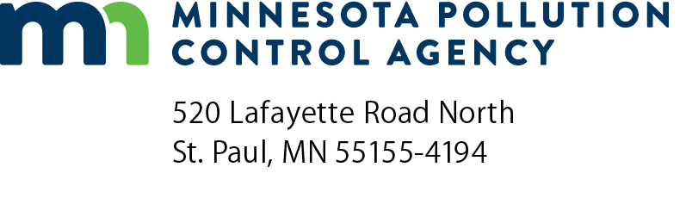 | NM-DRF  Deviations Identified Through Recordkeeping – Nonmetallic Mineral Processing General Permit  Air Quality Permit Program  Doc Type: Excess Emission Report
Instructions on Page 2.
Instructions: Refer to the Handbook and Application Instructions for the Part 70 Manufacturing General Permit for form instructions.
Sign this form, then create a PDF copy and email to: AQRoutineReport.PCA@state.mn.us.
For more information visit the Air permit compliance forms webpage.

General Facility Information
AQ Permit number: |  |  |  | Agency Interest ID number:
Facility name: |  |  |  |  | County:
 | Time period covered by report: January 1 - June 30 July 1 - December 31 |  |  |  |  | (year)
Summary of Deviations
All capacity, throughput (annual production) restrictions, non-process dust control requirements, limitations on fines crushing and producing or processing de minimis quantities of other material, along with associated recordkeeping, have been complied with at each stationary source as required by the Air Emission General Permit, except as identified below:
Date or period of associated event | Location of operation | Description of deviation and corrective action taken to bring stationary source into compliance
No entries are necessary. All capacity, throughput (annual production) restrictions, non-process dust control requirements, limitations on fines crushing and producing or processing de minimis quantities of other material, along with associated recordkeeping, have been completed at each stationary source.
Summary of Material Moisture Content
All testing, recordkeeping and required water application have been conducted at each stationary source as required by the Air Emission General Permit, except as identified below:
Date or period of associated event | Location of operation | Description of deviation and corrective action taken to bring stationary source into compliance

Notifications
The items listed in Table B of the Air Emission General Permit identify required notifications, such as those required by the New Source Performance Standard. These notifications include, in part, submittals such as Notifications of Commencement of Construction, Notification of Initial Startup, New Location Notifications, and any Performance Test Notifications. All submittals were made as required, in a timely manner, for each stationary source or piece of equipment except as identified below:
Date or period of associated event | Location of operation | Description of deviation and corrective action taken to bring stationary source into compliance
No entries are necessary. All required notifications were submitted to the MPCA in a timely manner.
Certification
I certify under penalty of law that this document and all attachments were prepared under my direction or supervision in accordance with a system designed to assure that qualified personnel properly gather and evaluate the information submitted. Based on my inquiry of the person or persons who manage the system, or those persons directly responsible for gathering the information, the information submitted is, to the best of my knowledge and belief, true, accurate, and complete.
Responsible official (please print):
Title:
Signature:
Phone: |  |  |  |  |  | Date:
Note: The individual signing must meet the definition of “responsible official” in Minn. R. 7007.0100, subp. 21.
Due dates: Air Emission Permit – General Nonmetallic Mineral Processing
- Deviation Report: January 30 and July 30
- Compliance Certification: January 31
General Information about Deviation and Compliance Reporting
Your permit requires that you submit deviation reports and an annual compliance certification. Use the “Deviation Reporting Forms” (abbreviated NM-DRF) and “Annual Compliance Certification Report”. These forms should be used unless you get Minnesota Pollution Control Agency’s (MPCA) approval to use another format.
NM-DRF is used to report deviations from permit conditions or deviations identified through recordkeeping (e.g., fuel use records).
NM-CR-04 is used to report your compliance status at the end of each year.
Please be sure that a responsible official, as defined in Minn. R. 7007.0100, subp. 21, signs all reports.

