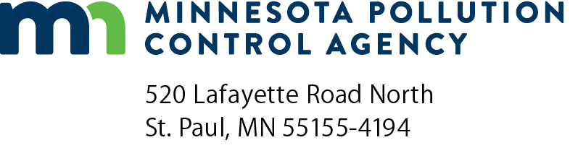 | NM-CR  Annual Compliance Certification Report –  Nonmetallic Mineral Processing General Permit  Air Quality Permit Program  Doc Type: Excess Emission Report
Further Instructions on Page 2.
Instructions: Refer to the Handbook and Application Instructions for the Part 70 Manufacturing General Permit for form instructions. Sign this form, then create a PDF copy and email to: AQRoutineReport.PCA@state.mn.us.
For more information visit the Air permit compliance forms webpage.
General Facility Information
AQ Permit number: |  |  |  | Agency interest ID number:
Facility name: |  |  |  |  |  | County:
This certification report covers the period of January 1 – December 31, |  |  |  |  | (year)
Deviation Reports Submitted to the MPCA
Type of  Deviation Report | Period covered by  Deviation Report | Date of cover letter accompanying Deviation Report
NM-DRF | January 1 through June 30
NM-DRF | June 30 through December 31
Certification
I certify under penalty of law, that I have reviewed the compliance status of all stationary sources covered by this general permit with respect to all permit conditions for the above-specified calendar year and have determined, to the best of my knowledge, that this permittee has been in continuous compliance with all permit conditions at each stationary source with the exception of those requirements listed in the above deviations reports which have been submitted to the Compliance Determination Unit Supervisor of the Minnesota Pollution Control Agency (MPCA).
Responsible official (please print):
Title:
Signature:
Phone: |  |  |  |  |  | Date:
Note: The individual signing must meet the definition of “responsible official” in Minn. R. 7007.0100, subp. 21.
General Information about Deviation and Compliance Reporting
Your permit requires that you submit deviation reports and an annual compliance certification. Use the “Deviation Reporting Forms” (abbreviated NM-DRF) and “Annual Compliance Certification Report.” These forms should be used unless you get MPCA approval to use another format.
NM-DRF is used to report deviations from permit conditions or deviations identified through recordkeeping (e.g., fuel use records).
NM-CR-04 is used to report your compliance status at the end of each year.
Please be sure that a responsible official, as defined in Minn. R. 7007.0100, subp. 21, signs all reports.
Form NM-CR Instructions
General information
AQ Permit number: Provide the first eight digits of the facility permit number.
Agency Interest ID number: Fill in your agency interest identification number. This is the number assigned to your facility through the Tempo database.
Facility name: Indicate the name of the facility covered by the report.
County: Indicate county where emissions facility is located.
Reporting year: Indicate the calendar year covered by the report.
Reports that were submitted to the Minnesota Pollution Control Agency (MPCA), and which included deviations:
Type of Deviation Report: Skip. Filled in with NM-DRF
Period covered by report: Skip. Filled in with appropriate dates.
Date of cover letter accompanying report: Specify the date the report was submitted to the MPCA.
Certification
Have the responsible official sign and date the form(s). “Responsible Official” is defined in Minn. R. 7007.0100, subp. 21.

