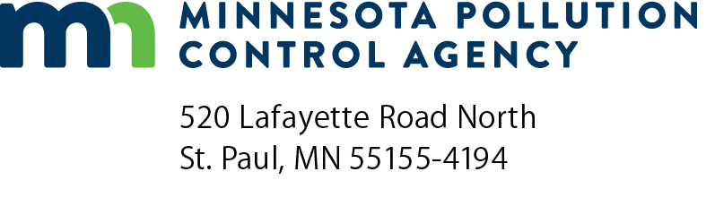 | MG-EIL  Part 70 Manufacturing General Permit equipment inventory list  Air Quality Permit Program  Doc Type: Permit

 |  |  |  |  | Date of this revision (mm/dd/yyyy):
a) AQ Facility ID number: |  |  |  | b) Agency Interest ID number:
c) Facility name:
- Facility equipment.
Type of equipment | Serial number | Manufacturer | Date of construction/ reconstruction  (mm/dd/yyyy) | Date of installation  (mm/dd/yyyy) | Which NSPS is the unit subject to? (if subject, attach a copy of the notifications) | Which NESHAP is the unit subject to? (if subject, attach a copy of the notifications) | Did you re-evaluate to determine if your actual emissions will remain below the thresholds in the permit? | Did you re-evaluate to determine if you still qualify for this permit?
NSPS = New Source Performance Standards, NESHAP = National Emission Standards for Hazardous Air Pollutant Sources

