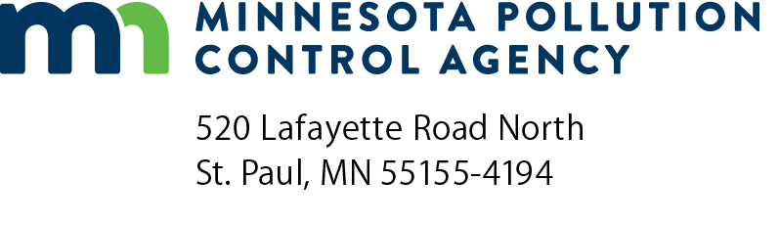 | CH-04  Determination of New Source Review Status  Air Quality Permit Program  Doc Type: Permit Application

1a) AQ Facility ID number: |  |  | 1b) Agency Interest ID number:
2) Facility name:
3) Is your facility defined as one or more of the following types of facilities? Please check any of the types of facilities that apply.
Some standard industrial classification (SIC) code(s) applying to specific categories are given in parentheses to assist you in classifying your facility. The SIC codes provided are not meant to be an exhaustive nor definitive list of facilities included in the category.
 | Coal cleaning plants-with thermal dryers |  | Kraft pulp mills (2611, 2621)
 | Portland cement plants (3241) |  | Primary zinc smelters (3339)
 | Iron and steel mills (3312) |  | Primary aluminum ore reduction plants (3334)
 | Primary copper smelters (3331) |  | Municipal incinerators capable of charging more than 250 tons of refuse per day
 | Hydrofluoric acid plants (2819, 2899) |  | Sulfuric acid plants (2819)
 | Nitric acid plants (2873) |  | Petroleum refineries (2911)
 | Lime plants (3274) |  | Phosphate rock processing plants (1475)
 | Coke oven batteries (3312) |  | Sulfur recovery plants (2819)
 | Carbon black plants (furnace process, 2895) |  | Primary lead smelters (3339)
 | Fuel conversion plants |  | Sintering plants*
 | Secondary metal production plants (334x, 332x) |  | Chemical process plants (28xx)**
 | Fossil-fuel boilers (or combination thereof) totaling more than 250 MMBtu/hr heat input |  | Petroleum storage & transfer units, total storage capacity over 300,000 barrels
 | Taconite ore processing plants (1011) |  | Glass fiber processing plants
 | Charcoal production plants (2819, 2861) |  | Fossil fuel-fired steam electric plants of more than 250 MMBtu/hr heat input
* Processing of fine grain materials into coarser lumps, performed primarily on ores
** Does not include ethanol production facilities that produce ethanol by natural fermentation included in NAICS codes 325193 or 312140.
Yes. My facility is classified as one or more of the 28 sources listed above. A listed air emission source having a potential to emit (PTE) 100 tons per year (TPY) or more of any single regulated New Source Review (NSR) pollutant (except carbon dioxide equivalents (CO2e)) is considered a major stationary source. For sources classified as one of the 28 listed, fugitive emissions must be included in the PTE. For item 6 of this form, and for form CH-04b if applicable, a 100-TPY emissions threshold must be used for all regulated NSR pollutants except CO2e.
No. My facility is not classified as one of the 28 sources listed above. An air emission source not classified as one of the 28 sources listed above and having the PTE 250 TPY or more of any single regulated NSR pollutant (except CO2e) is considered a major stationary source. For item 6 of this form, and for form CH-04b if applicable, a 250-TPY emissions threshold must be used for all regulated NSR pollutants except CO2e.
4) [Reserved]
5) [Reserved]
6) Is the current federally enforceable PTE (excluding greenhouse gas) of your facility greater than or equal to the thresholds identified in question 3, making your facility a major stationary source?
Yes. Go to question 7.
No. Go to question 9.
7) Is your facility currently covered by a permit that contains a Plantwide Applicability Limit (“actuals PAL”) as defined at 40 CFR § 52.21(aa)(2)(i) and (v)?
Yes. Go to question 8.
No. Go to question 9.
8) Are you able to continue to meet the emissions limits set by the Plantwide Applicability Limit after the project?
Yes. NSR is not applicable to the proposed change/modification. You need not complete the remainder of this form. You must determine if an amendment is needed under Minn. R. 7007.1150 – 7007.1500.
No. You must complete a Best Available Control Technology (BACT) analysis for all major and significant emissions units at your source. If installation of BACT still does not allow you to install the emission unit and maintain compliance with your PAL, you may apply for an increase in your PAL. Please see the Minnesota Pollution Control Agency (MPCA) forms on PALs at https://www.pca.state.mn.us/business-with-us/air-permit-application-forms or PAL information available here https://www.pca.state.mn.us/business-with-us/new-source-review, for guidance on increasing a PAL. Do not complete the remainder of this form.
9) Synthetic Minor Source: Are you proposing new or revised federally enforceable limits such that the entire facility (including the proposed modification) will become or remain a minor source?
Yes. Submit an application for a major amendment. Refer to the MPCA website at https://www.pca.state.mn.us/business-with-us/synthetic-minor-permit-limits for guidance on setting limits. Put proposed limits and proposed compliance demonstration on form CD-01. Do not complete form CH-04a. If you are revising an existing federally enforceable limit, complete form CH-04b to document emission changes.
No. If you answered “Yes” to question 6, go to form CH-04a.
If you answered “No” to question 6, go to form CH-04b.

