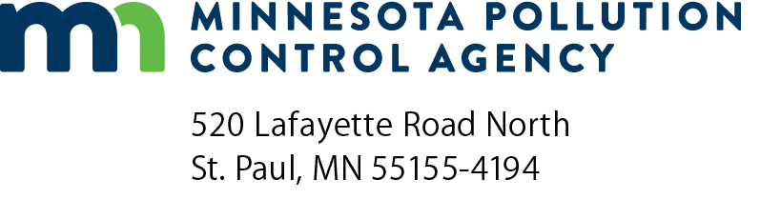 | SSTS Enforcement  Referrals from local programs  Subsurface Sewage Treatment Systems (SSTS) Program  Doc Type: Request for Information
Purpose/Instructions: The Minnesota Pollution Control Agency (MPCA) has created a process which allows Local Governmental Units (LGUs) to refer violation(s) of Subsurface Sewage Treatment System (SSTS) requirements to the MPCA. To facilitate this process, the MPCA has developed the following LGU referral process:
- The LGU should contact the MPCA regional SSTS enforcement staff to discuss whether or not the violation(s) falls under the authority of the MPCA. If the MPCA agrees that the violation falls under the authority of the MPCA, the LGU should complete the SSTS Enforcement Referral form and provide the necessary documentation.
- The referral form and any supporting documentation should be submitted via email or mail to the MPCA regional SSTS enforcement staff.
2. The MPCA regional SSTS enforcement staff will review the referral and supporting documentation and make a determination on what course of action the MPCA will take to respond to the violation(s).
- The resulting action may be a Letter of Warning, Notice of Violation, Citation, Administrative Penalty Order, Stipulation Agreement, Schedule of Compliance, or a License/Certification Sanction.
Note: Submission of the referral form does not guarantee that the MPCA will take the lead in following up on the violations, nor does it guarantee that an enforcement action taken by the MPCA will result in financial penalties or a license/certification sanction.
A list of the MPCA SSTS staff, their contact information, can be found on the MPCA website at: https://www.pca.state.mn.us/water/ssts-staff-mpca.
SSTS violation referral
Select the violation that you are referring:
Working without a license | Discharge to waters of the state
Septage/Land application violation | Straight pipe (relative to Minn. Stat. § 115.55)
Mentoring infraction | Failure to submit As-Built or inspection form within required timeframe
Failure to obtain local permit | Other:

Local program information

LGU and contact name:

Phone number:

Email:

Mailing address:
Required information for enforcement referral

[Red text is informational and can be deleted as the form is filled in.]

Regulated party name:

[This name should be the person who completed the action that resulted in noncompliance and, if applicable, the name of the SSTS licensed business that the person owns or is working for.]

Regulated party contact name:

[This name should be the person to whom the enforcement action will be mailed to. Typically this is the owner of the SSTS licensed business.]

Regulated party contact information:

Phone number:

Email:

Mailing address:

Date of violation(s) confirmation and method of discovery:

Site at which noncompliance occurred:

[If applicable, include locational information on where the noncompliance occurred, i.e., address, township, range, section, quarter section, parcels ID, etc.]
or NA
Documentation of violation(s)

[Include a detailed description of the events and documentation that led to the determination/discovery of noncompliance. Attach relevant documentation including: photos, sample results, inspection reports, maps, interviews, field letter of warning, etc.]

Correspondence relevant to the violation(s)

[List and attach documentation of all written correspondence or notes of conversations that occurred between the LGU and the regulated party relevant to the noncompliance.]

Inspection history

[If applicable, list date(s) and results of past LGU inspections. Attach any resulting inspection documentation.]
or NA

