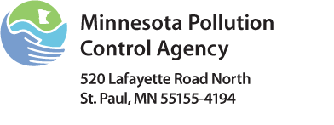 | SSTS Business License Surety Bond  Subsurface Sewage Treatment Systems (SSTS) Program  Doc Type: Bond and Bond Rider

Instructions on Page 3
Bond number: |  | Amount: | $25,000 | Effective date (mm/dd/yyyy):

KNOW ALL PERSONS BY THESE PRESENTS:
THAT
(Business name as registered with the Office of the Minnesota Secretary of State; or if individual sole proprietor, individual’s name.)
(DBA, doing business as name if applicable)
With business office at:
(Business address) (City) (State) (Zip) (Telephone number)
as Principal, and
(Name of Surety)
(Surety address) (City) (State) (Zip) (Telephone number)
a corporation authorized to do surety business in the State of Minnesota, as Surety, are hereby held and firmly bound to the State of Minnesota and any persons aggrieved, injured or suffering financial loss by reason of the Principal's failure to faithfully perform the duties, and in all things comply with all laws, ordinances, and rules, related to the Principal's license or any permit applied for and all contracts entered into, in the sum of TWENTY-FIVE THOUSAND DOLLARS ($25,000).
For the payment of this sum, Principal and Surety bind themselves, their heirs, representatives, successors and assigns, jointly and firmly by these presents.
THE CONDITION of the above obligation is such, that WHEREAS the said Principal is making application with the Minnesota Pollution Control Agency to be licensed as, or has been licensed as, a subsurface sewage treatment system business with specific privileges and responsibilities under Minnesota Statutes, sections 115.55 and 115.56, and 326B, as amended, Minnesota State Plumbing Code, as amended, Minnesota Rules, chapter 4715, as amended, and Minnesota Rules, chapters 7080 – 7083, as amended for all subsurface sewage treatment system and plumbing work entered into within the state.
NOW THEREFORE, if said Principal shall faithfully and lawfully perform the duties, and in all things comply with the laws and ordinances, including all amendments thereto, appertaining to the license or permit applied for and all contracts entered into, then this obligation shall be void; otherwise to remain in full force and effect.
The aggregate liability of the Surety, regardless of the number of claims made against the bond, shall in no event exceed the amount set forth above for each two year period the bond remains in force. The bond penalty shown above is cumulative over each two year period the bond remains in force, the same as if a separate bond were issued every two years.
PROVIDED, it is the intention of the parties that this bond be continuous. This bond may be canceled by the surety at any time upon giving the said Principal, the Minnesota Pollution Control Agency – 520 Lafayette Road North, St. Paul, MN 55155, and the Department of Labor and Industry – 443 Lafayette Road North, St. Paul, MN 55155 30 days written notice, said notice to be served by certified mail, whereupon, except as to any liabilities or indebtedness incurred prior to the termination of this said 30 days notice, the liability of the Surety under this bond shall cease. The Surety shall notify the Principal, the Minnesota Pollution Control Agency and the Minnesota Department of Labor and Industry, within 15 days of any bond claim, payment, or payment which results in the value of the bond falling below the legal requirement.
By their signatures below, the parties certify that the wording of this surety bond is in compliance with 7083.1000, Subp. 1, Item E, as the rules were constituted on the effective date of this bond. This bond shall be effective as of the effective date provided by the Surety in the field provided on this form and shall be in effect until cancellation. Effectiveness of this bond is only a component of, and does not constitute required licensure by the State of Minnesota. Principal shall not conduct work requiring licensure until the State of Minnesota has issued the license for which Principal has applied.
Signed and sealed this |  | day of |  |  | (Surety seal)
Print name of principal’s representative(s) |  |  |  |  | Signature of principal’s representative(s)
Print name of principal’s representative(s) |  |  |  |  | Signature of principal’s representative(s)
Acknowledge (notarize) signatures on reverse side and
attach power of attorney form.
File with: Minnesota Pollution Control Agency
520 Lafayette Road North
St. Paul, MN 55155
 |  |  |  |  | Name of Surety
 |  |  |  |  | Signature of Attorney in Fact (Surety Company)

A or B and C must be completed
- For Acknowledgement of IndividuaL, Partnership, Limited liability company or limited liability partnership (Note: All signatures must be notarized for Partnership. Please copy page if necessary)
State of |  |  |  |  | )
County of |  |  |  |  | )
On this |  |  | day of |  |  | , 20 |  |  | , personally appeared
to me well known to be the identical person(s) described in and who executed the foregoing bond, as Principal(s), and acknowledged to me that he/she/they executed the same to be his/her/their own free act and deed.

Signed,
Notary Public, |  |  | County,
My Commission expires
(Notarial Seal)
B. For Acknowledgement of a Corporate contractor
State of |  |  |  |  |  | )
County of |  |  |  |  |  | )
On the |  |  |  | day of |  |  |  |  | , 20 |  |  | , personally appeared
to me, who being duly sworn, did depose and say that he/she is the
of |  |  |  |  |  |  | , a
corporation; and that said instrument was executed in behalf of the corporation by authority of its Board of Directors; that he/she acknowledged said instrument to be the free act and deed of the corporation.

Signed,
Notary Public, |  |  | County,
My Commission expires
(Notarial Seal)
Part C must be completed by the Surety Company
C. FoR Acknowledgement OF Corporate Surety
State of |  |  |  |  |  | )
County of |  |  |  |  |  | )
On the |  |  | day of |  |  |  | , 20 |  |  |  | personally appeared
to me, who being duly sworn, did say that he/she resides in |  |  |  |  |  |  |  |  |  |  |  |  |  | that he/she is the aforesaid
officer or attorney in fact of |  |  |  |  |  |  |  |  |  |  |  | , the corporation whose name is affixed to the foregoing instrument;
that the seal affixed to the foregoing instrument is the corporate seal of said corporation; and that said instrument as signed and sealed in behalf of said corporation by the aforesaid officer, by authority of its board of directors; and the aforesaid officer acknowledged said instrument to be the free act and deed of said corporation.

Signed,
Notary Public, |  |  | County,
My Commission expires
(Notarial Seal)
***Surety Company Power of Attorney must be attached***
Instructions for Completing Subsurface Sewage Treatment System (SSTS) Surety Bond
The original ssts bond form must be filed with the ssts business license application – copies will not be accepted
If the principal is also applying for or maintains Plumbing Contractor licensure through the Department of Labor and Industry (DLI), a DUPLICATE ORIGINAL of their bond form may be executed and filed with the SSTS business license application.
The Surety Company must use a bond form provided by the Minnesota Pollution Control Agency (MPCA). There must not be an expiration date for the SSTS Business License Surety Bond. The bond shall be effective and run continuously from the bond’s effective date through the cancellation date established by the Surety Company. The Surety Company must provide 30-day notice of their established cancellation date to the licensee, the MPCA, and the DLI.
The MPCA bond form must be completed as follows:
- Bond Number: The Bond number must be issued. It cannot be marked as “pending.”
- Effective Date: The beginning date, inserted by the Surety, from which the Surety, Principle(s), and Obligees are bound by the conditions of the bond. Effectiveness of this bond is only a component of, and does not constitute required licensure by the State of Minnesota.
- The Name of Principal (Business name) including the assumed name (doing business as (dba)) shall be exactly the same as the applicant used on their “SSTS Business License Application” and all other forms. The business name that an applicant uses to identify themselves must be filed or registered with the Office of the Secretary of State. Note: Only individual (sole proprietor) or partnership business types using their own true full name(s) of the individual or all partners as part of the business name are not required to be registered with the Office of the Secretary of State. See below examples:
An individual sole proprietor without an assumed name – George Washington.
An individual sole proprietor with an assumed name – George Washington dba George Washington’s Honey Wagon.
An individual using their full first and last legal names in an assumed name as shown above is not required to register with the Secretary of State.
A partnership with an assumed name – John Doe and James Doe dba Two Brothers Septic Service.
A corporation or limited liability company– Leopold’s Septic Services, Inc. (LLC, LLP).
A corporation or limited liability company with an assumed named – Sequoia Environmental Services, LLC (Inc., LLP) dba John Muir Bobcat Digging.
- The address of the Business.
- The name of the Surety (Bonding) Company.
- The address of the Surety (Bonding) Company
- The date the Bond was signed and surety sealed by the power of attorney.
- Principal name and Signature. If the Business is an individual owner, the owner must sign bond; if a partnership, all partners must sign bond; if a limited liability partnership, all partners must sign bond; if a corporation, an officer must sign bond; and if another business entity, a person with delegated authority must sign bond. The individual(s) signing the bond for the business must be identified as the Owner(s), all Partners of partnerships, the Officer(s) of corporations (Inc), all Partners of limited liability partnerships (LLP), the Limited Liability Company Member(s) (LLC), and the Principal(s) of other business types as listed on the SSTS Business License Application.
- Name of Surety (Bonding) Company.
- Signature of Attorney in Fact (Surety Company).
- Very important! The bond form must be notarized as follows: (A) or (B) and (C) below:
- If the business is an Individual, Partnership, Limited Liability Company or Limited Liability Partnership, the bond form must be notarized in the block on the upper one-third of the form. All signatures need to be notarized. Please copy the page if necessary.
- If the business is a Corporation, the bond form must be notarized in the block in the center one-third of the form.
- The block in the lower one-third of the form must be notarized by the Surety Company.
- The original Power of Attorney form must be attached.
Note to Agent:
When the Surety Company completes the Bond, it must be returned to the Business to be signed by the Principal and properly acknowledged by a Notary Public. The bond must be notarized on the back in the appropriate block (Box A or B). Bonds that have the conditions of the Bond modified in any manner will not be accepted, and the application will be returned to the submitter.
Note to Surety Company:
Do not send bond form to the MPCA. Bond forms must be signed by the licensee before submission to the MPCA.

Bond examples
Individual Proprietors with an assumed name
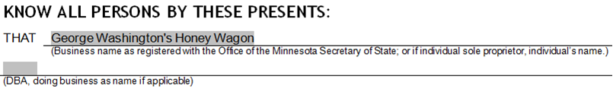
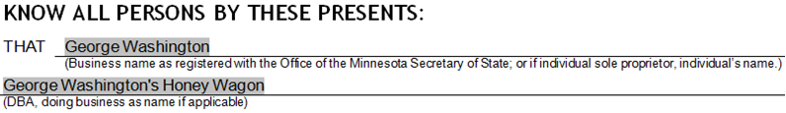
EXAMPLE
INCORRECT
EXAMPLE
CORRECT

Corporations or Limited Liability Companies without an assumed name
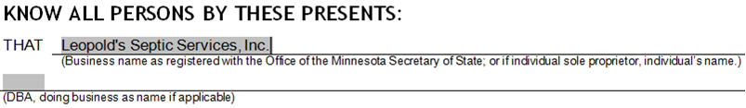
EXAMPLE
CORRECT
INCORRECT
EXAMPLE
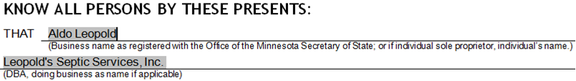

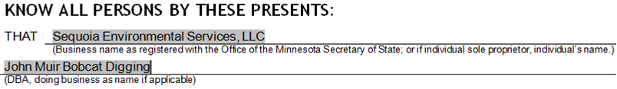
Corporations or Limited Liability Companies with an assumed name
EXAMPLE
INCORRECT
EXAMPLE
CORRECT
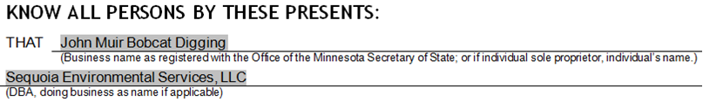

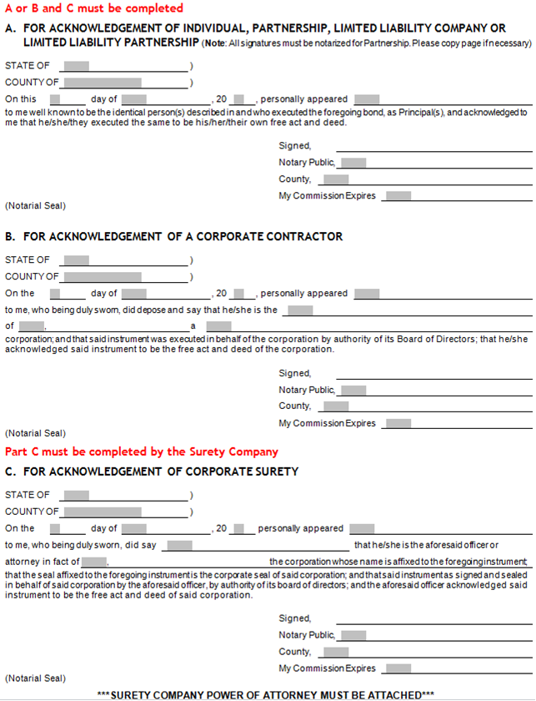

PART A or B MUST BE COMPLETED Depending on business structure type
PART C MUST BE COMPLETED BY THE SURETY COMPANY

