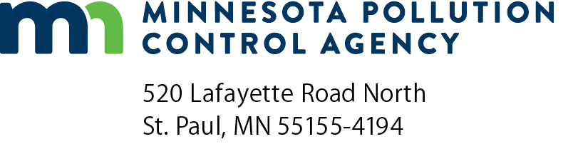 | Solid waste demonstration/research project proposal submission form  Solid Waste Program  Doc Type: Permit Application
Instructions: In early 2004, the Minnesota Pollution Control Agency (MPCA) completed amendments to Minn. R. ch. 7035 pertaining to solid waste. The amendments include provisions for limited-scale demonstration/research projects (DRPs) conducted to obtain information and data on new methods of solid-waste management. For example, a DRP may be conducted to evaluate a new landfill design, beneficial use, or solid waste management technology.
To apply for a DRP, write a proposal containing the required information listed in the following form. Make certain you indicate on the form where in your proposal the required information can be found. The MPCA will review and make a determination. If the project is approved, the MPCA will prepare an agreement, or issue a permit if required at the federal level.
If considering a beneficial use for your waste, check if the proposed use qualifies for a beneficial use determination already in place (Minn. R. 7035.2860, subp 4). These are briefly listed on page two of this form. If not listed, the project may qualify for a Case Specific Beneficial Use Determination (CSBUD) (Minn. R. 7035.2860, subp 5). Often, a CSBUD will first require applying for and completing a DRP. For more information about beneficial uses and DRPs, refer to the MPCA solid waste webpage: https://www.pca.state.mn.us/waste/demonstration-research-projects.
Submittal: Submit one (1) paper copy of the submittal package and one electronic (disk) to the Solid Waste Permit Document Coordinator at the address above.
Questions: Contact Greg Kvaal at 651-757-2511 or greg.kvaal@state.mn.us.
Organization information
Submittal date (mm/dd/yyyy):
Organization name: |  |  |  |  |  |  |  |  |  |  | Contact name:
Mailing address:
City: |  |  |  |  |  |  |  | State: |  |  |  |  | Zip code:
Phone: |  |  |  |  |  | Fax: |  |  | Email:
Consultant or additional contact: |  |  |  |  |  |  |  |  |  |  |  | P.E. number:
Mailing address:
City: |  |  |  |  |  |  |  | State: |  |  |  |  | Zip code:
Phone: |  |  |  |  |  | Fax: |  |  | Email:
DRP project proposal
Write a proposal using the information requirements listed below as a guide. Be certain to indicate on this form where in the proposal the required information appears.
Proposals must contain  the following information: | Page where info. appears | MPCA comments | MPCA determined complete
- Detailed description of the solid waste, manner in which it is generated and the solid waste technology or process to be evaluated.
- Results of appropriate chemical and physical characterization of the solid waste done in accordance with Minn. R. 7035.2861.
- Goals and objectives of the project.
- Scope of the project including length of time from the beginning of the project to completion, location, and quantity of solid waste involved.
- An outline of information that will be contained in a final report prepared at the end of the project.
- Review of literature related to the project.
- Experimental design.
- Proposed monitoring.
- Evaluation of possible environmental impacts. Description of safeguards proposed to protect health and the environment during, after the project.
- Verification that local units of government have been notified in writing of the intent to carry out the project and provided with information on whom to contact at the MPCA with questions.
- Verification that residents within a one-mile radius of the project have been notified prior to submitting the proposal to MPCA. Verification must consist of a copy of a notice placed in the local paper or any letter mailed to these residents. The notice or letter must include a brief description of the project and how to contact the MPCA to provide input or comments.
- When applicable, include information required by Code of Federal Regulations, title 40, part 258, for a research, development, and demonstration permit.
Summary of existing beneficial use determinations for solid waste
(Complete descriptions are available on the MPCA website at https://www.pca.state.mn.us/waste/standing-beneficial-use-determinations.)
- Unadulterated wood  - Unadulterated newspaper  - Uncontaminated glass for sandblasting  - Unusable latex paint  - Reclaimed glass and porcelain  - Crumb rubber  - Tire shreds  - Tire chips | - Uncontaminated recognizable concrete  - Salvaged bituminous  - Coal slag  - Coal fly ash  - Foundry sand for Portland cement  - Uncontaminated by-product limes  - Manufactured shingle scrap
MPCA Use Only
Use type: |  |  |  |  | Waste activity ID number:
Industry type (SIC code): |  |  |  |  | Project status:
Waste type: |  |  |  |  | Estimated annual amount of material:
Process type: |  |  |  |  | Technical review conducted by:

