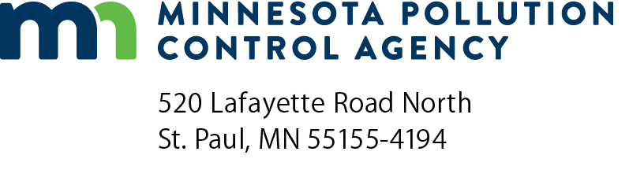 | Landfill Operator training  accreditation application  Landfill operator certification program  Doc Type: Learner assessment N2K

Instructions: Before completing the form, read the Landfill Operator Accreditation Policy on page two first. Below are the requirements for requesting approval of contact hours for the Landfill Operator Certification Program. To receive training program approval prior to the course, you must complete this form and submit the following information to the Minnesota Pollution Control Agency (MPCA) at least 60 days before the training event. Incomplete applications will be returned.
Please submit this completed form and attachments by email to sarah.lerohl@state.mn.us. Sarah Lerohl can be reached at the MPCA Training and Certification unit by telephone at 218-302-6617.

Accreditation
1. | Submit a written objective that describes the purpose of the training course and lists the expected learning outcomes for the participants.
2. | Submit a summary of credentials of the persons conducting the training. This should demonstrate the trainers’ knowledge about landfill operations.
3. | Submit a detailed course outline or agenda that lists start/stop times for each topic, including breaks/lunch.

Training information
Title: |  |  |  |  |  |  |  |  |  |  |  |  |  | Date (mm/dd/yyyy):
Location: |  |  |  |  |  |  |  |  |  |  |  | Instructor:
Employer:
Mailing address:
City: |  |  |  |  |  |  |  |  |  |  |  |  | State: |  | Zip code:
Phone: |  |  |  |  |  |  | Fax: |  |  | Email:
Course contact: |  |  |  |  |  |  |  |  | Direct: |  |  |  |  |  |  | Indirect:
Contact hours: |  |  |  |  |  |  |  |  |  |  | Requested:
After training is completed, the following must be submitted:
1. | A certificate of attendance to participants attending the entire session listing the training session, date, location, MPCA approved contact hours, participant’s name, and training instructor.
2. | A list of participants that attended the entire training program and actual start/stop times of each topic. Email to sarah.lerohl@state.mn.us.

MPCA use only:
Date received by MPCA (mm/dd/yyyy):
MPCA approved by: |  |  |  |  |  |  | Date approved:
MPCA approved contact hours |  |  | Direct: |  |  | Indirect:
MPCA comments:

Landfill operator accreditation policy
1. Classes that are facility or equipment-specific, which are to be used as license operational experience, will not be approved for accredited training hours.
Examples:
- Start-up equipment training, or
- Routine operation training for a specific landfill facility process
2. Training approval for on-the-job training sessions, which are not to be used for license operational experience, will be approved on a case-by-case basis. Approval is based on the application form submitted to the MPCA by the training provider.
3. Credit hours will be approved on the basis of full credit hours, not fractions of an hour. If the sum of the credit hour total is a fraction of an hour, it will be rounded down to the nearest hour.
4. Credit hours will not be approved for breaks, exams, assessments, any other non-training activity or tours of the facility where the attendees are employed.
5. Requests should be sent to the MPCA at least 60 days prior to the date of training. At the time that a request for credit hours is sent to the MPCA, the application must be complete. This includes the dates and times of the classes, a written objective of the class that describes the purpose of the training, lists the expected learning outcomes for the participants, the professional credentials of the trainers, and a specific time schedule (with session times, including breaks and lunch) of all sessions. The application request will be returned to the sender if it is not complete, and the 60-day time limit for MPCA approval will not begin until the request in sent back with all correct information.
6. Applications for accreditation of classes that were held prior to the time of request and approval are not guaranteed to be approved for hours requested, unless previous written agreements with the MPCA certification staff are applicable.
7. Requests from a single facility should go through facility coordinator to avoid multiple requests for the same classes. The MPCA will respond within 60 days of the receipt of the completed application. If additional information is required, the MPCA will notify the applicant as soon as possible.
8. When a pre-approved course is taught by a different instructor without the content of the course being changed in any way, a new application with the instructor's summary of credentials must be sent to the MPCA certification staff. The course may stay on the pre-approved list with the approval of the new instructor.
9. The certification staff at the MPCA reserves the right to audit any approved course at any time without advanced notice.

Requirements for accreditation of online training
Training provider must:
- Validate the identity, certification number, and participation of attendees seeking credit;
- Produce and disseminate a certificate of attendance that identifies the number and type of credits awarded by the MPCA;
- Share training records with the MPCA that identify each participant, certification number, and the number and type of credits awarded to each participant;
- Maintain training records for five years; and
- For synchronous training, submit a recording of the training session to the MPCA training coordinator.
Additional requirements required for accreditation of asynchronous training
Training provider must:
- Provide advanced access to online training for content review by accreditation team;
- Demonstrate the ability to track enrollment and progress individually by course/module;
- Ensure learners cannot skip ahead or fast forward through content;
- Require learners to verify acceptance of academic integrity policy (to be shared upon accreditation); and
- Ensure learners’ ability to interact with an instructor or expert, and access technical support to troubleshoot delivery platform or compatibility issues.

