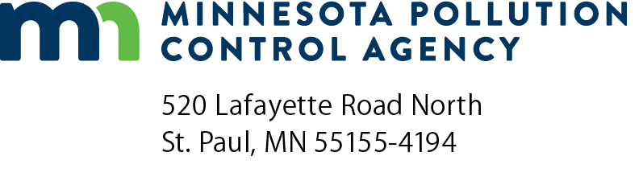 | Solid waste contact change form  Solid Waste Planning  Doc Type: Contact List
Instructions: Use this form to notify the Minnesota Pollution Control Agency (MPCA) about contact changes within your county/district. Keeping your county/district contacts up-to-date ensures that we can keep in contact on many timely and important topics and program updates. The person who completes this form should email the completed form to the county/district’s assigned solid waste planner, using “Contact change form” as the subject line. Save the completed form to your computer in a location where you can easily find it. If you have any questions in regards to the form, please contact Danielle Drussell at Danielle.drussell@state.mn.us or 218-302-6611.
County contact
Who should the MPCA contact with questions about this request:
Name:
Organization address: |  |  |  |  |  | County:
City: |  |  |  |  |  | State: |  |  |  | Zip code:
Contact phone: |  |  |  |  | Contact email:
Contact change type
Include new/updated contact information in “contact change requests” below. Any additional instructions should be included in the Comments section. Use a seperate change request section for each person.
Contact change request person 1
Addition – new contact; currently no contact association to facility
Removal – remove existing contact association to facility
Change – change to existing contact association to facility
Contact type
Select the contact type or types that apply.
SCORE  E-waste  Solid Waste Officer | Solid Waste Planner  Recycling/End Markets  Burn Barrel Program | Counties Involved in Source Reduction & Recycling (CISSR)  Recycling Education Committee  Household Hazardous Waste
All that apply (for removal only)
Contact type definitions:
All that apply = To completely remove an individual association with a County, for Removal option only.
Complete all fields, only one phone number required
Name:
Organization address: |  |  |  |  |  |  | County:
City: |  |  |  |  |  |  | State: |  |  |  |  | Zip code:
Office phone: |  |  |  |  | Mobile phone: |  |  | Email:
Comments:

Contact change request person 2
Addition – new contact; currently no contact association to facility
Removal – remove existing contact association to facility
Change – change to existing contact association to facility
Contact type
Select the contact type or types that apply.
SCORE  E-waste  Solid Waste Officer | Solid Waste Planner  Recycling/End Markets  Burn Barrel Program | Counties Involved in Source Reduction & Recycling (CISSR)  Recycling Education Committee  Household Hazardous Waste
All that apply (for removal only)
Contact type definitions:
All that apply = To completely remove an individual association with a County, for Removal option only.
Complete all fields, only one phone number required
Name:
Organization address: |  |  |  |  |  |  | County:
City: |  |  |  |  |  |  | State: |  |  |  |  | Zip code:
Office phone: |  |  |  |  | Mobile phone: |  |  | Email:
Comments:

Contact change request person 3
Addition – new contact; currently no contact association to facility
Removal – remove existing contact association to facility
Change – change to existing contact association to facility
Contact type
Select the contact type or types that apply.
SCORE  E-waste  Solid Waste Officer | Solid Waste Planner  Recycling/End Markets  Burn Barrel Program | Counties Involved in Source Reduction & Recycling (CISSR)  Recycling Education Committee  Household Hazardous Waste
All that apply (for removal only)
Contact type definitions:
All that apply = To completely remove an individual association with a County, for Removal option only.
Complete all fields, only one phone number required
Name:
Organization address: |  |  |  |  |  |  | County:
City: |  |  |  |  |  |  | State: |  |  |  |  | Zip code:
Office phone: |  |  |  |  | Mobile phone: |  |  | Email:
Comments:

