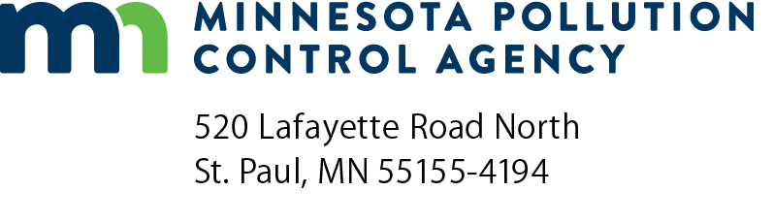 | Request for disposal of source separated recyclable material  Solid Waste Program  FY 2023  Doc Type: Request Form
Instructions: Complete this form and submit to MN.recyclingdisposalrequest.MPCA@state.mn.us
Once MPCA receives a request and the above information is complete, staff will review and make a recommendation to the Commissioner’s Office and a decision will be shared with the requestor. Requests for disposal are public information. The MPCA may decide to share certain aspects of the request with the media to ensure the public understands the unique reasons that led to the approval and trust in the recycling system is maintained.
- Requestor information
Requestor:
Address:
City: |  |  |  |  |  | State: |  |  | Zip code:
Mailing address (if different):
City: |  |  |  |  |  | State: |  |  | Zip code:
Contact Person: |  |  |  |  |  |  | Title:
Email: |  |  |  |  |  |  | Phone:
- Material for Disposal
2a. What type of material are you requesting to dispose of (Please be as specific as possible to avoid delays in processing your request)?
2b. How much material?
2c. Is this a one-time request or do you expect future requests?
- Geographic Location and/or Facility Information
3a. Where is the material located? Is it coming from a specific facility?
- Reason for Disposal
4a. Describe the reason for disposal of the recyclable material including the current end market used. If the reason is that the end market no longer takes the material, please describe other avenues that have been explored prior to this request, including contacting other end markets and potential capacity to store the material.
- Local Government Notification
5a. Is this request consistent with local ordinances and county policy/plans?
- Disposal Method
6a. What facility are you requesting for disposal?
6b. Has the chosen facility agreed to accept the material?

- Signature
Signature: |  | Date (mm/dd/yyyy):

