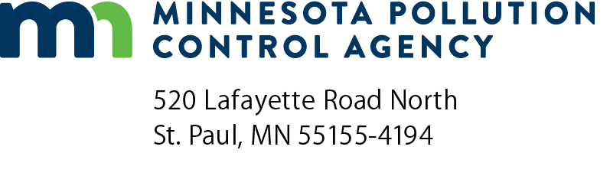 | Release information worksheet  Petroleum Remediation Program  Guidance document 2-05  Doc Type: Environmental Development/Guidance
Instructions: Complete this worksheet to document tank and release information as required by the public record provision of the Energy Policy Act of 2005. Submit the completed worksheet as an appendix to either the General excavation report worksheet, Investigation report, or Monitoring report. These report forms are found on the Minnesota Pollution Control Agency (MPCA) Cleanup guidance webpage at https://www.pca.state.mn.us/waste/cleanup-guidance.
A. General information
Site name: |  | MPCA Site ID: | LS00
B. Tank material
Check all that apply:
Steel Fiberglass
C. Piping material
Check all that apply:
Steel Fiberglass Flexible plastic Copper Other (specify):
D. Identify the known source(s) of the release or contamination encountered
Check options that were verified. If source is unknown, check other and describe.
Piping Tank Dispenser Submersible turbine pump Delivery problem
Other (specify):
E. Identify the cause of the release (tank and/or piping)
Check all that apply.
Overfill Mechanical or physical damage Install problem Corrosion Spill Unknown
Other (specify):
F. Identify how the release was detected
Check all that apply.
Removal Line leak detection Tank leak detection Visual/Olfactory Site assessment
Other (specify):
G. Has the site ever stored E85 in any former or current tank? Yes No Unknown
H. Has the site ever stored leaded gasoline in any former or current tank? Yes No Unknown

