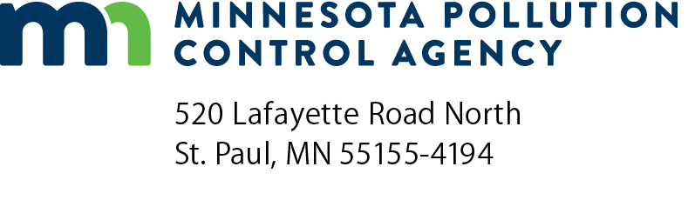 | MG-09B  Part 70 Manufacturing General Permit  Requirements: NESHAP (40 CFR § 61)  Air Quality Permit Program  Doc Type: Permit Application

National Emission Standards for Hazardous Air Pollutants (NESHAPS) Requirements for Source Categories

(NESHAP, 40 CFR § 61)
Refer to the Handbook and application instructions for the Part 70 Manufacturing General Permit for form instructions.

Facility information
a) AQ Facility ID number: |  |  | b) Agency Interest ID number:
c) Facility name:

Applicable requirement determination
1) Part 61 NESHAPS were the regulations in existence before the 1990 Clean Air Act Amendments. They apply only to air emission sources listed in Table C (attached) that emit the pollutants listed. Table C contains:
- a pollutant;
- a facility description;
- a Minnesota Rules reference;
- a Code of Federal Regulation 40 § 61 (40 CFR § 61) subpart reference.
2) Read through Table C. If your facility emits any of the listed pollutants, and your facility type, process or equipment matches those associated with the pollutant, a 40 CFR § 61 NESHAP may apply to you. To determine if a standard applies to your facility, refer to the corresponding 40 CFR § 61 subpart(s) and Minnesota Rules listed and read the requirements in detail.
3) After reviewing the NESHAP reference list and reading the corresponding 40 CFR § 61 subpart(s) check one of the following boxes:
NO, my facility is not subject to 40 CFR § 61 NESHAP requirements; go to Form MG-09 question 2b.
YES, my facility (or a portion of it) is subject to 40 CFR § 61 NESHAP requirements. The facility is not eligible for this general permit.

Table C
National Emission Standards for Hazardous Air Pollutants
Pollutant | Facility or emission unit type | Minn. R. | 40 CFR § 61 subp.
Radon | Underground Uranium Mines; Department of Energy Facilities; Phosphogypsum Stacks; and Facilities Processing or Disposing of Uranium Ore and Tailings | 7011.9960 | B, Q, R, T, W
Beryllium | Beryllium Extraction Plants; Ceramic Plants, Foundries, Incinerators, Propellant Plants, and Machine Shops that Process Beryllium Containing Material; and Rocket Motor Firing Test Sites | 7011.9940 | C, D
Mercury | Mercury Ore Processing; Manufacturing Processes Using Mercury Chloralkali Cells; and Sludge Incinerators | 7011.9950 | E
Vinyl Chloride | Ethylene Dichloride Manufacturing Via Oxygen, HCl and Ethylene; Vinyl Chloride Manufacturing; and Polyvinyl Chloride Manufacturing | 7011.9980 | F
Radio-Nuclides | Department of Energy; Nuclear Regulatory Commission Licensed Facilities; Other Federal Facilities; and Elemental Phosphorus Plants | 7011.9970 | H, I, K
Benzene | Fugitive Process, Storage, and Transfer Equipment Leaks; Coke By-Product Recovery Plants; Benzene Storage Vessels; Benzene Transfer Operations; and Benzene Waste Operations | 7011.9930 | J, L, Y, BB, FF
Asbestos* | Asbestos Mills; Roadway Surfacing with Asbestos Tailings; Manufacture of Products Containing Asbestos; Demolition; Renovation; and Spraying and Disposal of Asbestos Waste | 7011.9920 -7011.9927 | M
Inorganic Arsenic | Glass Manufacturer; Primary Copper Smelter; Arsenic Trioxide and Metallic Arsenic Production Facilities | 7011.9910 | N, O, P
Volatile Hazardous Air Pollutants (Vhap) | Pumps, Compressors, Pressure Relief Devices, Connections, Valves, Lines, Flanges, Product Accumulator Vessels, etc. in VHAP Service (As of 11/30/94 only vinyl chloride and benzene are regulated by 40 CFR 61, subp. V) | 7011.9990 | V
*If you are only subject to 40 CFR § 61.145 (subp. M Standard for Demolition and Renovation), because you are doing asbestos abatement, you do not need a Minnesota Air Emission Permit, but you must contact the Minnesota Department of Health at
612-627-5097 and the asbestos team at the Minnesota Pollution Control Agency at 612-297-8685 before beginning any abatement activity.

