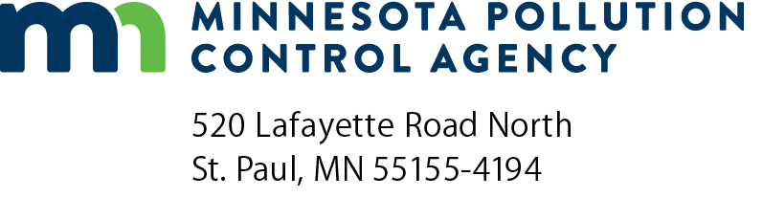 | CH-01  Change description  Air Quality Permit Program  Doc Type: Permit Application
Instructions: Provide below a description of each physical and operational change, or proposed change to existing permit conditions, included in this application. This includes addition of new units, removal or replacement of existing units, or changes which may result in debottlenecking of emission units. Use form CH-02 to determine if a permit amendment is required for your proposed change or modification.
1a) AQ Facility ID number: |  |  | 1b) Agency Interest ID number:
2) Facility name:
3) Does your project involve any of the following? Check all that apply.
Construction or physical change.
Increase in production.
Other operational change.
Fuel change.
None of the above. Go to question 5.
4) Does your project involve the addition or modification of a non-emergency generator?
No.
Yes. You must conduct screening modeling for the generator or group of generators. See instructions.
5) Do you need your permit issued by a certain date?
No.
Yes. Date (mm/dd/yyyy):
Reason:

6) Complete and attach form CD-01 to specify which applicable requirements need to be added to or deleted from your permit unless the application is for a change in ownership, a change in facility name, or an extension of a deadline by no more than 120 days. The deadline must be one which Minnesota Pollution Control Agency (MPCA) has authority to extend. If the application is only for a change in ownership, a change in facility name, or an extension of a deadline by no more than 120 days, form CD-01 does not need to be included. Instead, include this information in the description below.
7) Description of proposed project, including details of all changes indicated in question 3:

Form CH-01 instructions
1a) AQ Facility ID number – Fill in your Air Quality Facility ID number. This is the first eight digits of the permit number for all permits issued under the operating permit program.
1b) Agency Interest ID number – Fill in your agency interest identification (ID) number. This is an ID number assigned to your facility through the Tempo database. If you don’t know this number, leave this line blank.
2) Facility name – Enter your facility name.
3) Does your project involve any of the following?
Physical changes: Physical changes include but are not limited to the following types of activities:
- Installation or replacement of emission units (for example, adding or replacing a boiler). Remember that when adding new equipment, even if it is a replacement for an existing emission unit, it should be numbered consecutively starting with the next number following the last one used – do not renumber existing units, or reuse numbers from removed equipment.
- Installation or replacement of control equipment (for example, removing a cyclone and installing a baghouse in its place, or adding a control device where none existed before). Remember that when adding new control equipment, even if it is a replacement for an existing unit, it should be numbered consecutively starting with the next number following the last one used – do not renumber existing units, or reuse numbers from removed equipment.
- Removal of existing emission units or control equipment.
- Changes to existing emission units (for example, replacing a burner on a boiler with one of higher capacity or which can burn different fuels).
- Changes which may not always be apparent from a visual inspection (for example, changing the catalyst in a chemical reactor).
- Changes which may result in applicable requirements no longer applying (for example, disconnecting fuel oil supply pipes from a boiler so that the boiler can only operate on natural gas).
Increases in production: An increase in production is a type of change that may increase emissions but is not a physical change. It is generally a change in operation that increases utilization of existing equipment beyond what is authorized by the permit.
Examples of increases in production include, but are not limited to, the following:
- increasing a production rate
- increasing the throughput of materials
- increasing fuel usage
- increasing hours of operation
Examples of changes which are not increases in production:
- increasing production when there is not an existing permit condition limiting production, throughput, fuel usage, or hours of operation
Other operational changes: Operational changes are any type of change a source can make which might increase emissions and which is not a physical change or an increase in production as described above.
Examples of operational changes include but are not limited to:
- changing to solvents with higher PM, VOC, or HAP contents than those used in previous permit applications
- using a different chemical in the production of a product for which the equipment is already in place
- increasing hours of operation or production rate when there is a permit condition which limits the hours of operation or production rate
Examples of changes which are not operational changes include:
- routine maintenance, repair and replacement
- some fuel switching may be exempt from being considered a modification if the fuel switch is required by certain federal regulations
Fuel changes: Fuel changes include, but are not limited to, the following:
- adding a new fuel that is not specifically authorized by the permit
- replacement of a currently permitted fuel with a different fuel
- changing the specifications of a fuel that is authorized by the permit where the specifications are included in the permit (e.g., fuel sulfur content)
4) Does your project involve the addition or modification of a non-emergency generator? – The MPCA requires screening modeling (or refined modeling, if needed) for all non-emergency generators. Use Form EC-03, found on the MPCA Emission Calculations webpage (http://www.pca.state.mn.us/dm0rdc9). Engines being tested in test cells are not considered non-emergency generators.
5) Do you need your permit issued by a certain date? – If you need to have a permit issued by a particular date, enter that date and describe the importance of that date.
6) Compliance demonstration (CD-01) form – The CD-01 form will contain a listing of all applicable requirements for your modification. Refer to the total facility application instructions for more information on how to propose synthetic minor permit limits. If you previously submitted an air emission permit application, you may have completed a form CD-01 for the emission unit you are now planning to modify or remove. If the removal means some applicable requirements no longer apply, you should indicate that on form CD-01, either by copying the original form CD-01 and marking “delete” by the applicable requirement that no longer applies, or by stating this on a new form CD-01. Be sure to indicate this type of change and the applicable requirements that no longer apply.
7) Description of proposed project – Provide a description of each physical and operational change and/or proposed change to existing permit conditions included in this application. Include any effects from “debottlenecking” emission units.
Debottlenecking - If the installation of a new emission unit or changes to an existing unit have the effect of allowing other emission units at the facility to operate at a higher capacity than utilized, this is called debottlenecking. Describe how the capacity of these other units will increase.
Other changes – Even if you aren’t making a physical or operational change, you may still need a permit amendment in order to implement your proposed project. For example, if you wish to revise or delete existing permit conditions, you must apply for the appropriate permit amendment. Describe these changes here.

