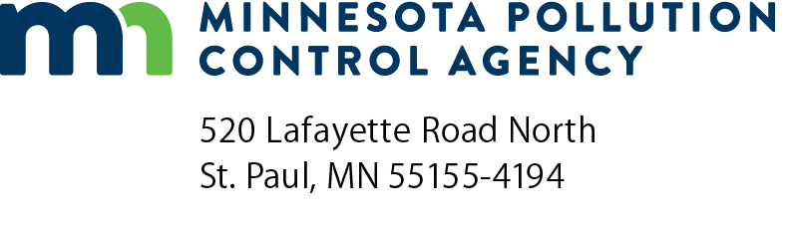 | GI-09E  Acid Rain Requirements (40 CFR pt. 72)  Air Quality Permit Program  Doc Type: Permit Application
Acid Rain Program under Title IV
(1990 Clean Air Act, as amended, Sections 401-416)

Utilities and other facilities which combust fossil fuel and generate electricity for wholesale or retail sale may be subject to acid rain program requirements, including the requirement to hold an acid rain permit under 40 CFR pt. 72. Utilities designated as "Phase I" or "Phase II" sources will need to apply for an acid rain permit. Other facilities that may be permitted include certain new units that began commercial operation on or after November 15, 1990, and existing units that increase electric generation from less than 25 megawatts to 25 megawatts or more. Certain cogeneration units, qualifying facilities, independent power facilities, and solid waste incinerators may need to apply for a permit. Subject facilities must fill out the Phase II Permit Application Forms developed by EPA. If you need these application forms, they can be found on the EPA’s web site at https://www.epa.gov/airmarkets/business-center-forms.

New utility units with an electricity generating capacity not greater than 25 megawatts and that burn only fuels with sulfur content of 0.05 percent or less by weight may be exempted from acid rain requirements. If you qualify for this exemption, fill out the New Unit Exemption Form. You may also apply for an exemption of retired utility units; to do this, follow the procedures outlined in
40 CFR § 72.8.

For additional information, please refer to the acid rain applicability definition at 40 CFR § 72.6.

Facilities may petition EPA for an acid rain applicability determination. Petitions must conform to EPA requirements and should be sent by the facility's certifying official. Contact EPA on how to go about doing this. A list of EPA contacts for a variety of topics is available online at https://www.epa.gov/airmarkets/business-center-and-emissions-monitoring-contacts

Anything related to Acid Rain permits that must be sent to EPA should go to the following addresses:

Street address (overnight mail and package delivery):
US EPA
Clean Air Markets Division
1201 Constitution Avenue, NW
Room 7231B
Washington, DC 20004
Telephone: 202-343-9790

Regular or certified mail:
US EPA
Clean Air Markets Division
1200 Pennsylvania Avenue, NW
Mail Code 6204M
Washington, DC 20460

Check EPA’s website for updates to addresses at https://www.epa.gov/acidrain/forms/contact-us-about-acid-rain.

