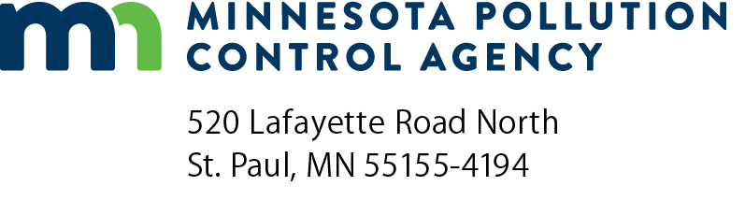 | CD-03  Compliance Schedule  Air Quality Permit Program  Doc Type: Permit Application

Instructions on Page 2.
1a) AQ Facility ID No.: |  |  | 1b) Agency Interest ID No.:
2) Facility Name:

3) Compliance Schedule:

3a) | 3b) | 3c) | 3d) | 3e)
Emission unit or stack/vent ID number | Citation of requirement with which you are not in compliance | What corrective action(s) will you take, and by when? | How will you measure progress toward compliance? | Progress report submittal schedule

Instructions for Form CD-03
1a) AQ Facility ID No. -- Fill in your Air Quality (AQ) Facility Identification (ID) Number (No.). This is the first eight digits of the permit number for all permits issued under the operating permit program.
1b) Agency Interest ID number -- Fill in your Agency Interest ID number. This is an ID number assigned to your facility through the Tempo database. If you don’t know this number, leave this line blank.
2) Facility Name -- Enter your facility name.
3) In this table you will provide the information required for your compliance schedule that will explain to the MPCA how you will achieve compliance with those air quality rules and regulations with which your facility is currently out of compliance.
You should have completed Form CD-02 Compliance Certification, in which you identified specific rules and regulations with which you are in or out of compliance. In filling out Form CD-03, you will again identify any applicable requirements with which your facility currently is not in compliance and explain how/when you will bring your facility into compliance with those requirements. If you are in compliance with all rules and regulations that apply to your facility, you do not need to complete Form CD-03.
Your compliance schedule will contain:
- steps you will take to achieve compliance;
- dates when you will achieve these steps;
- how your progress toward compliance will be measured; and
- proposed schedule for submitting progress reports to the MPCA.
Important points to keep in mind when preparing your compliance schedule:
- propose specific steps and dates for correcting the violation(s);
- your schedule should be practically achievable and needs to show the MPCA that you are striving to attain compliance in the shortest period of time possible;
- your schedule must show that you will be able to practically measure your progress through appropriate recordkeeping, monitoring, reporting practices; and also specify how often you will report your progress to the MPCA (the rules require at a minimum progress reports to be submitted to the MPCA on a semi-annual basis);
- your schedule begins the day you submit your application; comply with your schedule as soon as you submit it.
Remember that your schedule must be enforceable. This is why it is essential that you are able to measure your progress through appropriate monitoring, recordkeeping and reporting practices. Non-specific goals and indefinite time frames are not enforceable and may cause your application to be deemed incomplete.
Start taking steps immediately to correct any violations. If violations are corrected before you submit the permit application, you will not need to develop a compliance schedule or certify noncompliance with the associated rule or regulation. If you do begin your corrective action early, document your activities.
3a) Emission Unit, Stack Vent--Enter the emission unit(s) (EQUI xxx, FUGI xxx) or stack vent(s) (STRU xxx) identification number that is out of compliance. Use the same identification number provided on Form CD-01.
3b) Citation of requirement with which you are not in compliance -- Cite the rule, regulation, or other regulatory basis of the applicable requirement.
3c) What corrective action(s) will you take, and by when? Propose specific steps to correct the violation(s). Include specific dates for completing these steps. The MPCA requires that any recordkeeping, monitoring, and reporting practices must be practical and measurable. Make sure your schedule allows you to achieve compliance within the shortest time frame possible or the form may be returned to you.
3d) How will you measure progress toward compliance?-- Describe how you will determine that you achieved the corrective actions described in item 3c).
3e) Progress report submittal schedule -- Describe how often you will submit reports to the MPCA describing your compliance status.

