Septage Review Checklist
NPDES/SDS Permit Program
National Pollutant Discharge Elimination System (NPDES)/
State Disposal System (SDS)
Doc Type: Plan/Specification Review Summary
Purpose: This checklist is intended for use by design engineers, to assist Minnesota Pollution Control Agency (MPCA) review engineers in the efficient review of planning and design documents. The information requested is the minimum technical data necessary for MPCA staff to review proposed designs and to determine whether there is reasonable assurance that the treatment system, when constructed, will comply with permit conditions, regulations, and criteria of the MPCA.
Instructions: The information in this checklist is based on the Recommended Standards for Wastewater Facilities published by the Great Lakes Upper Mississippi River Board of State and Provincial Public Health and Environmental Managers (Ten State Standards) 2014 Edition, other accepted engineering references, and MPCA recommendations. Specific references, other than Ten State Standards, are listed where appropriate. The checklist is organized according to the numbering sequence found in Ten State Standards to allow for ease in locating the entire content and text of the recommendations.
The checklist is designed so that a “yes” answer indicates compliance with Ten State Standards et al.
A “no” answer indicates a deviation from Ten State Standards et al. Answering “no” to any question will require justification that can be provided at the end of the checklist and possibly supporting information, from wastewater treatment plant operational data, to demonstrate how the intent of the recommendation will be met. Additional information may be requested based on site specific conditions.
A “N/A” answer means not applicable because the equipment associated with the question is not included in the design.
Wastewater Treatment Facility information
Date (mm/dd/yyyy): |  |  | MPCA Project No:
Title of project:
Permittee information
Facility name:
Contact name and title: |  | NPDES/SDS Permit No: | MN
Email: |  | Phone number:
Design Engineer information
Contact name and title: |  | Contact phone number
Email:
Phase: Planning Phase Design Phase
Appendix: Handling and Treatment of Septage at a Wastewater Treatment Plant
(Only use a “NA” answer if the equipment associated with the question is not included in the design)
- General | Yes | No
Are special design considerations made at the wastewater treatment plant prior to the acceptance of septage?

- Definition
Septage is a general term for the contents removed from septic tanks, portable vault toilets, privy vaults, holding tanks, very small wastewater treatment plants, or semi-public facilities (i.e., schools, motels, mobile home parks, campgrounds, small commercial endeavors) receiving wastewater from domestic sources. Non-domestic (industrial) wastes are not included in the definition.
 | Yes | No | N/A
Are contents from grease traps excluded from disposal at the wastewater treatment plant?

- Characteristics
Compared to raw domestic wastewater from a conventional municipal sewer collection system, septage usually is quite high in organics, grease, hair, stringy material, scum, grit, solids, and other extraneous debris. Substantial quantities of phosphorus, ammonia nitrogen, bacterial growth inhibitors, and cleaning materials may be present in septage, depending on the source. Refer to Tables No. 1 and No. 2 (reprinted from the U.S. EPA Handbook entitled “Septage Treatment and Disposal” 1984, Tables 3-4 and 3-8) for a comparison of common parameters for septage and municipal wastewater.

 |  |  |  | Yes | No | N/A
Are data collected for design of septage receiving and treatment systems for local septage to be received?
Is it acknowledged that the characteristics of septage should be expected to vary widely from load to load depending on the source?
- Treatment
Septage is normally considered treatable at a plant.
Has proper engineering planning and design been provided to evaluate shock loadings or other adverse impacts on plant processes and effluent quality?
Design flow of WWTP: |  |  | mgd
Design flow of septage: |  |  | mgd
Design CBOD loading to WWTP: |  |  | lb/day
Design CBOD loading/ft² (if ponds): |  |  | lb/day/ft²
Is there sufficient capacity (mgd) of the plant relative to the amount and rate of septage directed to the plant?
Is there unused plant capacity available (above current sewer collection system loadings) to treat septage loadings?
Is there sensitivity of the treatment plant process to daily fluctuations in loadings brought about by the addition of septage?
Will slug septage loadings of BOD, ammonia nitrogen, or phosphorus cause process upset, odor nuisance, aeration tank/aerated digester foaming, or pass through to the effluent?
Are feasible alternative points of feed to the treatment units evaluated including feed to the sludge processing units provided the unit function will not be adversely affected?
Is there the ability to control feed rates of septage to the plant for off peak loading periods?
Has the volume and concentrations of bacterial growth inhibitors in septage from portable vault toilets and recreational dump station holding tanks been considered?
Volume of bacterial growth inhibitors: |  |  | gpd
Concentration of bacterial growth inhibitors: |  |  | mg/L
Have the permitted plant effluent limits been considered when evaluating these factors?
- Considerations
Has an adequate engineering evaluation been conducted of the existing plant and the anticipated septage loading prior to receiving septage at the plant?
Have local approvals been obtained prior to the acceptance of septage?
For a proposed plant expansion and upgrade, does the Engineering Report or Facility Plan include anticipated septage loading when addressing treatment plant sizing and process selection?
Has it been determined that the uninterrupted and satisfactory treatment (within the plant regulatory limits) of waste loads from the sewer system shall not be adversely affected by the addition of septage to the plant?
Has consideration been given to the size of the plant because, in general, the smaller the plant design capacity relative to the septage loading, the more subject the plant will be to upset and potential violation of permitted discharge effluent limits?
Has the allocation of organic plant capacity originally planned for future growth been considered?
Has the sensitivity of the treatment process to receiving septage and the impact on discharge parameter limits been jointly considered for plants to be expanded and upgraded?
Has an evaluation of available plant operating personnel and the staffing requirements necessary when septage is to be received been conducted?
Will plant staff be present when septage is received and unloaded?
Has added laboratory work associated with receiving septage for treatment been included in the staffing and laboratory facilities evaluation?
Has an evaluation of space available for constructing septage receiving facilities that are to be off-line from the raw wastewater from the sewer system been conducted?
Has other plant activity and traffic flow been considered when locating the septage receiving facility and the septage hauler unloading area?
Has the impact of the septage handling and treatment on the plant sludge handling and processing units and ultimate sludge disposal procedures been evaluated?
- Receiving Facility
Is the hard surface haul truck unloading ramp sloped to a drain to allow ready cleaning of any spillage and washing of the haul tank, connector hoses, and fittings?
Is the unloading ramp area designed and sloped to minimize collection of stormwater?
Is there a flexible hose fitted with easy connect coupling to provide for direct connection from the haul truck outlet to minimize spillage and help control odors?
Is washdown water with ample pressure, hose and spray nozzle available for convenient cleaning of the septage receiving station and haul trucks?
Is the use of chlorinated effluent considered for cleaning of the septage receiving station and haul trucks?
If a potable water source is used for cleaning the septage receiving station and haul trucks, is it protected in accordance with Paragraph 56.2?
Is an adequate off-line septage receiving tank designed to provide complete draining and cleaning by means of a sloped bottom equipped with a drain sump provided?
Does the design of the off-line receiving tank consider adequate mixing for testing, uniformity of septage strength, chemical addition (if necessary), for treatability and odor control?
Is the capability to collect a representative sample of any truck load of waste accepted for discharge at the plant provided?
Will the operator have authority to prevent and/or stop any disposal that is likely to cause an effluent violation?
Will screening, grit, and grease removal of the septage as appropriate to protect the treatment units be provided?
Will pumps for handling the septage be nonclogging and capable of passing 3-inch diameter solids?
Will valving and piping be provided with operational flexibility to allow the control of the flow rate and point of septage discharge to the plant?
Will safety features to protect the operation personnel (refer to Section 57) be provided?
Will the receiving area be fenced and locked?
Will laboratory and staffing capability be provided to determine the septage strength and/or toxicity to the treatment processes and provisions for operation reports to include the plant load attributed to septage?

Justification for all questions answered with a “no”:
Additional comments:

References
GLUMRB (2014 Edition) Recommended Standards for Wastewater Facilities (Ten State Standards), Health Research, Inc., Health Education Services Division, Albany NY
U.S. EPA (1984), Handbook: Septage Treatment and Disposal, U.S. EPA Municipal Environmental Research Laboratory, Cincinnati OH. (U.S. EPA 1984)
Acronym definitions
BOD Biochemical Oxygen Demand
CBOD Carbonaceous Biochemical Oxygen Demand
gpd gallons per day
lb/day pounds per day
lb/day/ft² pounds per day per square foot
mgd million gallons per day
mg/L milligrams per liter

Basic Layout of Dumping Station (U.S. EPA 1984)

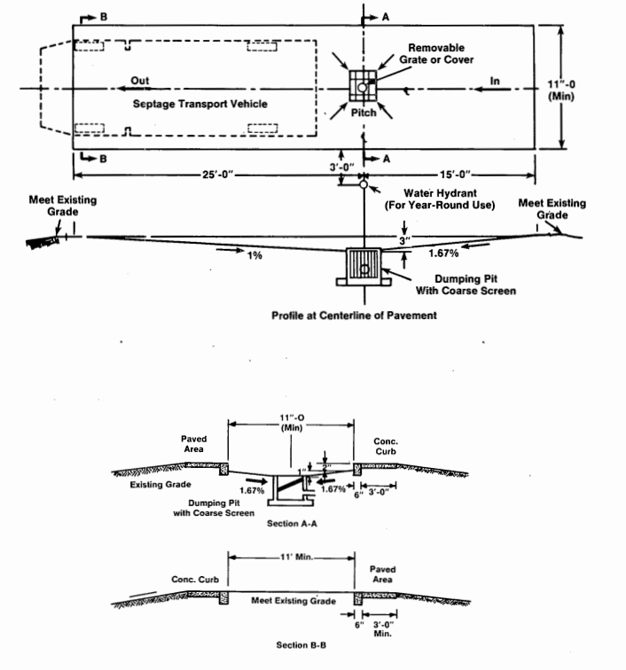

Dumping Station Inlet Arrangement (U.S. EPA 1984)
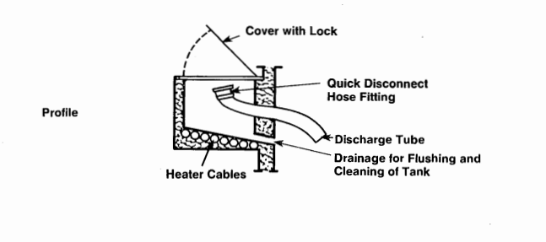

Computerized Interceptor Receiving Station (U.S. EPA 1984)

