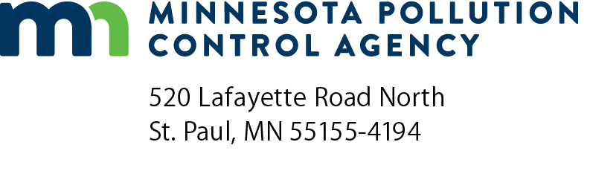 | Project Priority List (PPL)  Wastewater Application  Doc Type: Wastewater Point Source
Instructions: Submit completed form to ppl.submittals.pca@state.mn.us.
For more information, please contact Bill Dunn, Clean Water Revolving Fund Coordinator at 651-757-2324 or bill.dunn@state.mn.us. You can also visit our website at: https://www.pca.state.mn.us/business-with-us/apply-for-financial-assistance
1. | New project/Update to existing PPL project: |  |  |  |  | New project Update to existing project Rescore
 |  |  |  |  | MPCA Project number:
2. | NPDES/SDS Permit number:
3. | Project description:
4. | Facility Plan/Preliminary Engineering Report submitted along with PPL Application? |  |  |  |  |  |  |  |  |  |  | Yes No
5. | Applicant name:
 | Project area:
 | Town/city:
 | Population:
 | County:
6. | Contact person:
 | Address:
 | Phone:
 | Email:
7. | Project engineering consultants/Firm name (if applicable):
 | Contact name:
 | Address:
 | Phone:
 | Email:

8. | Project area description: | Sewered | Unsewered (submit map of project area)
 | a. Number of existing households:
 | b. Number of non-residential users:
 | c. Number of failing SSTS systems: | N/A

 | Need or problem project addresses:  (Check all that apply) | Rehab collection system | Failing SSTS systems
 |  | Connection to an existing system | Rehab of an existing facility
 |  | New treatment and/or collection system | Advanced treatment
 |  | Expansion of existing treatment plant | Other
 | Note: Required attachments for unsewered area projects. A map of the project service area which has an identifiable scale, identifies all the structures with wastewater flows, and has the maximum impact zone clearly encircled.

9. | Project estimated cost ($):
10. | Current project status:
11. | Desired construction state date, if financing is available (month/year):
12. | Project Needs Categories (check all that apply):
New Collector System
New Interceptors
Sewer System Rehab
Infiltration/Inflow
Secondary Treatment
Advanced Treatment
Reuse
Water Efficiency
Energy Efficiency
Renewable Energy
13. | Please indicate if this project may qualify for Green Project Reserve (GPR), and has potentially eligible components or the entire project is applying to be determined GPR eligible.
 | The U.S. Environmental Protection Agency (EPA) has provided a guidance document listing examples of projects that will qualify for Green Project Reserve dollars. Below is an abbreviated list of those examples. If the proposed project matches one or more of the examples, check the box next to the example that describes the project. For more information, see Guidance for Green Project Reserve at https://www.pca.state.mn.us/business-with-us/apply-for-financial-assistance.

Categorical eligible project types (check all that apply):
1. Water Efficiency
2. Energy Efficiency
3. Environmentally Innovative
4. Non-categorical (describe below)
On behalf of an eligible project as their authorized authority, I hereby submit this application for placement on the PPL:
Authorized Representative
Signature: |  | Title:
 | (This document has been electronically signed.)
Email: |  | Date (mm/dd/yyyy):

