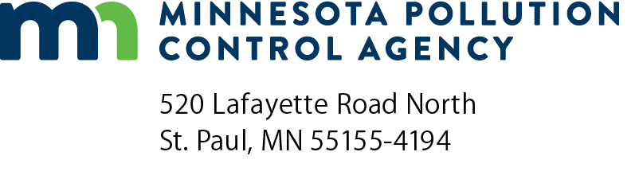 | CWRF facilities plan submittal checklist  Clean Water Revolving Fund (CWRF) Program  Submissions Required for a Complete Facilities Plan  Minn. R. 7077.0272

Instructions: The Facilities Plan may be submitted via email at ppl.submittals.pca@state.mn.us (and one hard copy submitted to the assigned Minnesota Pollution Control Agency [MPCA] Review Engineer).
Facility information
Project name:
Proposed dates for construction:
City’s authorized representative:
Title: |  |  |  |  |  |  |  |  |  | Telephone:
Mailing address:
City: |  |  |  |  |  |  |  | State: |  |  | Zip code:
Technical agent or consulting engineer:
Name of firm/organization: |  |  |  |  |  |  |  |  |  | Telephone:
Check yes or no for the following questions
Is the Facilities Plan signed by an engineer registered in the State of Minnesota? Yes No
Has the municipality in which the facility will be located held at least one public hearing to discuss the proposed project?
Yes No If yes, what was the date the hearing was held:
Check the boxes below if you have included the following items
If all of the following items are not included with the Facilities Plan, the Facilities Plan is incomplete and may be returned or filed until a complete submittal is received. Facilities Plan review will not begin until a complete submittal is received. Please see Minn. R. 7077.0272 for more information about the content of facilities plan.
The following forms can be found on the MPCA website at https://www.pca.state.mn.us/water/wastewater-financial-assistance.
A completed CWRF cost and effectiveness certification checklist provided by the MPCA.
A completed CWRF B3 2030 exemption form provided by the MPCA.
A completed CWRF cost and effectiveness certification form provided by the MPCA.
A summary of the public hearing documenting that the following items were discussed:
The various treatment alternatives considered
The location of the project site
The reasons for choosing the selected treatment method
The estimated sewer service charges
A summary of the comments received at the public hearing and the action taken to address those comments.
A complete list of addresses used for public notice purposes on a form provided by the MPCA.
A copy of the resolution of the municipality’s governing body adopting the facilities plan.
A list of ordinances or intermunicipal agreements required for the implementation and administration of the project.
A signed treatment agreement with each significant industrial user.
For surface water dischargers only, a copy of the Preliminary Effluent Limits review letter provided by the MPCA.
- Contact the MPCA to determine if a formal request for Preliminary Effluent Limits needs to be made for the project.
- The alternatives analysis should address antidegradation requirements if the project is proposing an increase in flow or loading.
A completed Environmental Information Worksheet provided by the MPCA.
For individual sewage treatment systems that serve more than one structure, an assurance from the municipality stating that all property owners who will be served by the proposed system agree to be part of the system, to participate in the construction project, and to finance future operation, maintenance, and replacement of the system.
Copies of all notifications, certifications, and comments received.

