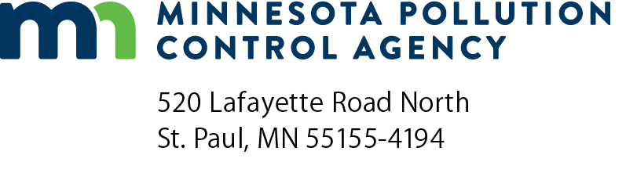 | Industrial non-contact cooling  water notice of intent  general permit application  NPDES/SDS General MNG250/MNG255000 Permits  Doc Type: Permit Application

Eligibility criteria: “Non-contact cooling water” is water used to reduce temperature that does not come into contact with a raw material, intermediate product, waste product other than heat, or finished product. It includes water used in most air conditioning equipment. “Non-contact cooling water” does not include cooling water that comes into contact with cans, bottles, product, etc. For eligibility under the non-contact cooling water general permit, the only pollutants added are heat and approved water treatment chemicals. If you answer yes to any of the following questions, your waste stream is not eligible for coverage under the non-contact cooling water general permits; and you must complete an Industrial Non-Contact Cooling Water Application (wq-wwprm7-28) found on the Minnesota Pollution Control Agency (MPCA) website at https://www.pca.state.mn.us/business-with-us/wastewater-permit-forms.

Is this a recycled cooling water waste stream, such as bleed-off from cooling tower?

Is this a contact cooling water waste stream?

Other than chlorine or bromine, are toxic water treatment chemicals added to the cooling water?

If an industry, is the waste stream regulated by federal categorical effluent limitation guidelines?

Instructions: If no boxes were checked above, complete this application form by typing or printing in black ink. Attach additional sheets as necessary.

Review the application to ensure all requested items are submitted with this application.

Please make a copy for your records.

Refer to the Transmittal Form for mailing instructions.

For more information, please contact the MPCA at: in Metro Area: 651-296-6300 or outside Metro Area: 800-657-3864. To learn more about how you can participate in the NPDES permitting process, please visit the MPCA website at https://www.pca.state.mn.us/sites/default/files/wq-wwprm1-32.pdf. (Minn. Stat. § 115.03, subd. 5d.)
General information
Permittee name: |  |  | Permit number: | MN
Principal activity, product, or business: |  |  |  | SIC code:
Water supply
Cooling water source
 | Groundwater Surface water Municipal water supply
 | If surface water, list name of surface water:
 | Is the water supply chlorinated? Yes No
 | DNR Water Appropriation Permit No.: |  |  | Expiration date: |  | No Exp. Date
 |  |  |  |  | (mm/dd/yyyy)

Type of cooling system (e.g., heat exchangers, ammonia compressors) | Volume of discharge  (gallons/day) |  | Final disposal of cooling water  (e.g., name of receiving water body)
 | Average | Maximum
Cooling water discharge
Number of separate discharge points to surface/groundwater:

Cooling system type | Hours/Day | Days/Week | Weeks/Year | Duration, if other than year-round (e.g., May-Oct)

Chemical additives
List below the chemical additives that are used or proposed to be used in the cooling water process regulated by this permit. This includes the descaling agents, corrosion inhibitors, biocides, fungicides, algaecides, refrigerants, detergents, softening agents, etc. that are added to the intake water source. MPCA approval is required for any additives that are new, increasing in usage, or not previously approved. Go to the chemical additive approvals section at: https://www.pca.state.mn.us/business-with-us/wastewater-permit-additional-guidance-and-information to find the documents necessary to complete the approval process. Your additives will not be approved for use until you complete this process.
Product name | Purpose | Location in process of chemical addition | Frequency of addition | Type of application (slug dosing or continuous feed) | Average rate of use (weight or volume per day) | Maximum rate of use (weight or volume per day) | Previously approved?  Yes or no | Date of approval  (mm/dd/yyyy)
 |  |  |  |  |  |  | Yes No
 |  |  |  |  |  |  | Yes No
 |  |  |  |  |  |  | Yes No
 |  |  |  |  |  |  | Yes No
An Additional Chemical Additives attachment is available on the MPCA website at https://www.pca.state.mn.us/business-with-us/wastewater-permit-forms, if more space is needed.
The following items shall be submitted with this application form. It is not sufficient to cite that such items have been previously submitted. Failure to submit these materials will result in rejection of the permit application.
A map, preferably a USGS quadrangle showing the location of the facility and the route to the receiving water body. If the discharge is to a storm sewer, you may need to contact the municipal authority to learn the storm sewer route from your facility to where the storm sewer discharges to surface water.
A simple, schematic diagram (flow chart) showing the cooling water flow, from point of intake through the cooling water process to the discharge point from the facility. Indicate on this flow chart the point at which sampling of the cooling water discharge occurs.
Monitoring results for temperature, pH and Total Phosphorus (irrespective of water source or whether or not such analysis is now required). If a municipal water supply, or if a chlorine or bromine based biocide is used, provide an analysis for Total Residual Oxidant as Chlorine, from a sample taken at the point of discharge from the facility, using a test method with a method detection limit of at least 0.001 mg/L, irrespective of whether or not such analysis is currently required.

