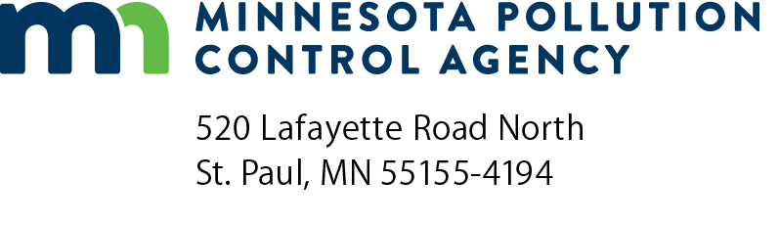 | Sewage tank integrity assessment form  Subsurface Sewage  Treatment Systems (SSTS) Program  Doc Type: Compliance and Enforcement

Purpose: This form may be used to certify the compliance status of the sewage tank components of the SSTS. This form is not a complete SSTS inspection report, only a tank integrity assessment, and may only certify sewage tank compliance status when entirely completed and signed by a qualified professional. SSTS compliance inspection report forms can be found at: https://www.pca.state.mn.us/water/inspections.
Instructions: This form may be completed, and signed, by a Designated Certified Individual (DCI) of a licensed SSTS inspection, maintenance, installation, or service provider business who personally conducts the necessary procedures to assess the compliance status of each sewage tank in the system. Only a licensed maintenance business is authorized to pump the tank for assessment. A copy of this information should be submitted to the system owner and be maintained by the licensed SSTS business for a period of five (5) years from the assessment date.
When this form is signed by a qualified certified professional, it becomes necessary supporting documentation to an Existing System Compliance Inspection Report: Compliance inspection form - Existing system (wq-wwists4-31b). This form can be found on the MPCA website at https://www.pca.state.mn.us/water/inspections.
The information and certified statement on this form is required when existing septic tank compliance status is determined by an individual other than the SSTS Inspector that submits an inspection report. This form represents a third party assessment of SSTS component compliance and is allowable under Minn. R. 7082.0700, subp. 4(B)(1). This form is valid for a period of three years beyond the signature date on this form unless a new evaluation is requested by the owner or owner’s agent or is required according to local regulations. Additional Administrative Rule references for this activity can be found at Minn. R. 7082.0700, subp. 4(B),(C), and (D) and; Minn. R. 7083.0730(C).
Owner information
Owner/Representative
Property address:
Local Regulatory Authority: |  |  |  | Parcel ID:
System status
System status on date (mm/dd/yyyy):
Certificate of sewage tank compliance |  |  |  |  | Notice of sewage tank non-compliance
Compliance criteria:
The SSTS has a seepage pit, cesspool, drywell, leaching pit, or other pit - “Failure to Protect Groundwater.” |  |  |  |  |  |  |  |  | Yes* No
The SSTS has a sewage tank that leaks below the designed operating depth - “Failure to Protect Groundwater.” |  |  |  |  |  |  |  |  | Yes* No
The SSTS presents a threat to public safety by reason of structurally unsound (damaged, cracked, or weak) maintenance hole cover(s) or lids or any other unsafe condition - “Imminent Threat to Public Health or Safety.” |  |  |  |  |  |  |  |  | Yes* No
Any “yes” answer above indicates sewage tank non-compliance.
Company information |  |  |  |  |  | Designated Certified Individual (DCI) information
Company name: |  |  |  |  |  | Print name:
Business license number: |  |  |  |  |  | Certification number:

I personally conducted the work described above as a Designated Certified Individual of a Minnesota-licensed SSTS inspection, maintenance, installation, or service provider Business. I personally conducted the necessary procedures to assess the compliance status of each sewage tank in this SSTS.
By typing/signing my name below, I certify the above statements to be true and correct, to the best of my knowledge, and that this information can be used for the purpose of processing this form.
Designated Certified Individual’s signature: |  |  |  |  |  |  |  | Date (mm/dd/yyyy):
 |  |  |  | (This document has been electronically signed.)

