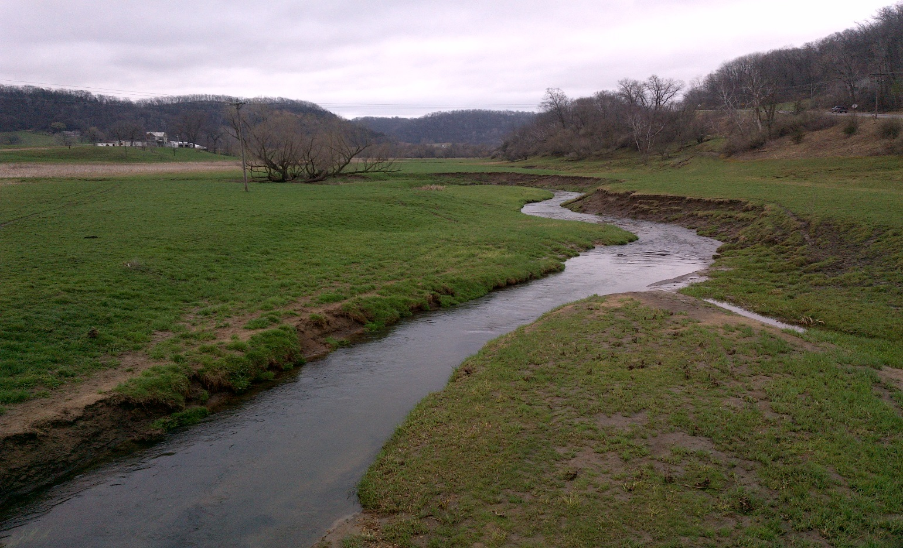
[Picture(s) can be inserted into this space. Right click on this picture, choose change picture, click on the picture you want and then insert. Resize/Crop the picture to fit this area.]
[Month and year of report]

[Insert Watershed] Stressor Identification Report
A study of local stressors limiting the biotic communities in the [Insert Name] Watershed.
Watershed

Guide to template structure
[Prior to beginning this report, please check with local partners, project managers and Stressor ID staff (if a consultant is contracted for the SID Report) to verify the most useful organization structure (i.e., organized by AUID or candidate causes). Section 4 outlines some criteria for cases where the report should be organized by AUID or candidate causes.]
[This SID Report Template is designed to simplify the SID Report writing process by providing guidance on content and structure as well as adding some consistency to reports written by various affiliates. The text bracketed in red directs the author(s) to example information or type of content that is applicable for a given section of the report. Any text appearing in red in this template should be deleted when the report is completed.]
[The checklist below contains items that are easily overlooked, but should be completed prior to submitting the final report. We suggest reviewing this checklist prior to beginning the SID Report to provide additional guidance on key items. Delete this page when the report is finalized.]
General:
- Have two Stressor ID Staff review this report?
- Are the IBI thresholds and confidence intervals for fish/macroinvertebrates used in the analyses included in the report? Alternatively, it’s okay to reference that information if it’s provided elsewhere (e.g., in the Monitoring and Assessment Report?). (Note: It is important to clearly state the specific thresholds and confidence intervals used in the current SID analyses in the event that these numbers change in the future.)
Formatting:
- Have the Table of contents, List of tables and List of figures been updated?
- Has the month and year been inserted into the footer?
- Is the resolution on all figures appropriate?
- All elements of the tables/figures are legible?
- Have all tables and figures been referenced in the text?
- Are x and y axes of figures clearly labeled with units?
- Captions – placed on top of all tables and beneath all figures. They should be numbered in consecutive order.
- Are all the references cited in the report listed in the References page?
- Has the spelling and grammar been checked?
- Is the Clean Water Legacy Logo on the cover? (If funded locally this is not required)
- Please use sentence case and PCA styles within this template. Examples cited here:

Executive summary (PCA Report Heading 1 – Sentence case Calibri Bold 22 spacing 0/3 pt)

PCA Report Heading 2 (Sentence case) Calibri Bold 16, spacing 18 pt/6 pt

PCA Report Heading 3 (Sentence case) Calibri Bold 14, spacing 12 pt/3 pt

PCA Report Heading 4, standalone (Sentence case) Calibri Bold 12 spacing 8pt/0pt
PCA Report Heading 4 in-line (Sentence case) Calibri Bold 12 spacing 8pt/0pt
PCA Report Heading 5 (Sentence case)
PCA Report Heading 6 (Sentence case)
PCA Body Text = Calibri 11 spacing 0 points before/6 points after (line spacing exactly at 14 pt)
PCA Figure/Table title Calibri 10 bold spacing 6 points before/6 points after. [Figure and table titles should appear above image/table.]
PCA Table heading Calibri 10 bold 3/0 | PCA Table heading | PCA Table heading
PCA Table text Calibri 10 3/0 | PCA Table text | PCA Table text
PCA Table text | PCA Table text | PCA Table text
PCA Table text | PCA Table text | PCA Table text
*PCA text under Table/Figure Calibri 10 spacing 3 pts before/6 points after.
- Table lines = Style: Solid; Color: Automatic; Width: ¼ pt.
- Before/after spacing 3/0
- Try to align bottom left first; however, this is flexible due to the different tables we encounter.
- Repeat header on the top of each succeeding page in the table, when possible

Authors
Principal author
Other author
Other author

Contributors/acknowledgements
Name
Name

Editing and graphic design
PIO staff
Graphic design staff
Administrative staff

Cover photo credit

The MPCA is reducing printing and mailing costs by using the Internet to distribute reports and information to wider audience. Visit our website for more information.
MPCA reports are printed on 100% post-consumer recycled content paper manufactured without chlorine or chlorine derivatives.

Foreword
Insert Foreword language here if there is one. Otherwise, delete.

Contents
Foreword i
Contents ii
List of tables iii
List of figures iv
Key terms & abbreviations v
Executive summary vi
1. Introduction 1
1.1. Monitoring and assessment 1
1.2. Stressor identification process 2
1.3. Common stream stressors 4
1.4. Report format 5
2. Overview of [Insert Name] Watershed 6
2.1. Background 6
2.2. Monitoring overview 8
2.3. Summary of biological impairments 11
2.4. Hydrological Simulation Program - FORTRAN Model 12
3. Possible stressors to biological communities 14
3.1. Eliminated causes 14
3.2. Inconclusive causes 14
3.3. Summary of candidate causes in the [Insert name] Watershed 14
4. Evaluation of candidate causes 16
4.1. AUID #1 16
4.2. AUID #2 [repeat sequence] 17
4.3. Identification of probable causes 17
4.4. Conclusion 17
5. Evaluation of candidate causes 18
5.1. Candidate cause #1 (e.g., High phosphorus) 18
5.2. Candidate cause #2 [repeat sequence] 19
5.3. Identification of probable causes 19
5.4. Conclusion 19
6. Conclusions and recommendations 20
6.1. Summary of probable stressors 20
6.2. Recommendations 20
7. References 21
8. Appendix 22

List of tables
Table 1. Common streams stressors to biology (i.e., fish and macroinvertebrates). 4
Table 2. Biologically impaired AUIDs in the [Insert name] Watershed. [Insert additional horizontal lines as needed.] 11
Table 3. Fish classes with respective IBI thresholds and upper/lower confidence limits (CL) found in the [Insert name] Watershed. [Example: Hawk Creek SID Report] 11
Table 4. Macroinvertebrate classes with respective IBI thresholds and upper/lower confidence limits (CL) found in the [Insert name] Watershed. [Example: Hawk Creek SID Report] 12
Table 5. Fish and macroinvertebrate IBI scores by biological station within AUID. Key to color coding in Table 6. [Insert additional rows as needed.] 12
Table 6. Key to color coded IBI scores. 12
Table 7. Summary of probable stressors in the [Insert name] Watershed. [Insert additional rows as needed.] 20
Table 8. Recommended prioritization of TMDLs relative to the stressors contributing to the biological impairment in the [Insert name] Watershed. [Example: Ann River SID Report] 20
Table A1. Values used to score evidence in the stressor identification process. [Example: MS River/Lake Pepin SID Report]. 22
Table A2. Strength of evidence Scores for various types of evidence [Example: MS River – Lake Pepin SID Report]. 22
Table A3. Biological metrics included in the SID process. [This table must be shown in the SID Report until it is published elsewhere, at which point, it can then be referenced through a hyperlink. Table A3 must be referenced in the main body of the report. Example: MS River-Lake Pepin SID]. 23
Table A4. Strength of evidence table for candidate causes. [This table could take many forms – a single table for all causes evaluated or multiple tables – chosen format is optional, but it should mimic the organizational structure of Section 4 for consistency. Example: Yellow Medicine River.] 24
Table A5. Summary of biological assessments. [Only show this table if it contains new info since Monitoring and Assessment Report. Example: MS River – Lake Pepin SID Report.] 25

List of figures
Figure 1. Process map of IWM, Assessment, SID and TMDL processes. [Insert applicable years into the appropriate Phase I and Phase II boxes.] 1
Figure 2. Conceptual model of SID process (Cormier et al. 2000). 2
Figure 3. Map showing management units in the [insert name] Watershed. [Multiple options will be possible for figures in this section. Refer to the minimum required elements described in Section 2.1 for guidance. Example: Mississippi River-St Cloud SID Report.] 7
Figure 4. Map of agroregions/watershed zones within the [North Fork Crow River] Watershed. [This example will not be applicable to all SID reports. Multiple options will be possible for figures in this section. Refer to the minimum required elements described in Section 2.1 for guidance.] 8
Figure 5. Map of monitoring stations in the [Insert name] Watershed. [Example: Le Sueur River SID Report.] 9
Figure 6. Map of impaired AUIDS in the [Insert name] Watershed. [Multiple options will be possible for figures in this section. Refer to the minimum required elements described in Section 2.1 for guidance.] 10
Figure 7. HSPF modeled subwatersheds. [Example: Yellow Medicine River SID Report. Delete if HSPF modeling was not conducted in this watershed.] 13
Figure 8. Dissolved oxygen diurnal fluctuation at select North Fork Crow/Crow River sites based on longitudinal (synoptic) monitoring completed in 2010. 15

Key terms & abbreviations
[Insert applicable key terms as needed with brief definitions here]
CADDIS Causal Analysis/Diagnosis Decision Information System
EPA U.S. Environmental Protection Agency
IWM intensive watershed monitoring
MPCA Minnesota Pollution Control Agency
SID stressor identification
SOE strength of evidence
TMDL total maximum daily load
WRAPS Watershed Restoration and Protection Strategy

Executive summary
Over the past few years, the Minnesota Pollution Control Agency (MPCA) has substantially increased the use of biological monitoring and assessment as a means to determine and report the condition of the state’s rivers and streams. This basic approach is to examine fish and aquatic macroinvertebrate communities and related habitat conditions at multiple sites throughout a major watershed. From these data, an Index of Biological Integrity (IBI) score can be developed, which provides a measure of overall community health. If biological impairments are found, stressors to the aquatic community must be identified.
Stressor identification (SID) is a formal and rigorous process that identifies stressors causing biological impairment of aquatic ecosystems and provides a structure for organizing the scientific evidence supporting the conclusions (Cormier et al. 2000). In simpler terms, it is the process of identifying the major factors causing harm to aquatic life. SID is a key component of the major watershed restoration and protection projects being carried out under Minnesota’s Clean Water Legacy Act.
This report summarizes SID work in the [Insert watershed name] Watershed.
[Insert brief description of the watershed (land use, number of impairments, etc.) and how it was evaluated. Include 1-2 sentences on how the report is organized (i.e., report is organized by candidate causes or by AUID. Keep total length of Executive Summary to 1-2 pages].
After examining many candidate causes for the biological impairments, the following stressors were identified as probable causes of stress to aquatic life:
[Insert bullet list of stressors that were identified as probable stressors to biological communities.]

- Introduction
  - Monitoring and assessment
Water quality and biological monitoring in the [Insert watershed] have been ongoing for [insert time period]. As part of the MPCA’s Intensive Watershed Monitoring (IWM) approach, monitoring activities increased in rigor and intensity during the years of [year-year], and focused more on biological monitoring (fish and macroinvertebrates) as a means of assessing stream health. The data collected during this period, as well as historic data obtained prior to [insert year], were used to identify stream reaches that were not supporting healthy fish and macroinvertebrate assemblages (Figure 1.).
Once a biological impairment is discovered, the next step is to identify the source(s) of stress on the biological community. A SID analysis is a step-by-step approach for identifying probable causes of impairment in a particular system. Completion of the SID process does not result in a finished total maximum daily load (TMDL) study. The product of the SID process is the identification of the stressor(s) for which the TMDL may be developed. In other words, the SID process may help investigators nail down excess fine sediment as the cause of biological impairment, but a separate effort is then required to determine the TMDL and implementation goals needed to restore the impaired condition.
Figure 1. Process map of IWM, Assessment, SID and TMDL processes. [Insert applicable years into the appropriate Phase I and Phase II boxes.]
TMDL/WRAPS
IWM Phase I
([Insert years])
Identify Biological Impairments
Assessment Process
IWM Phase II
([Insert years])
Stressor identification:
Identify causes of biological impairments
Historic Data
  - Stressor identification process
The MPCA follows the U.S. Environmental Protection Agency’s (EPA’s) process of identifying stressors that cause biological impairment, which has been used to develop the MPCA’s guidance to SID (Cormier et al. 2000; MPCA 2008). The EPA has also developed an updated, interactive web-based tool, the Causal Analysis/Diagnosis Decision Information System (CADDIS; EPA 2010). This system provides an enormous amount of information designed to guide and assist investigators through the process of SID. Additional information on the SID process using CADDIS can be found here: http://www.epa.gov/caddis/
SID is a key component of the major watershed restoration and protection projects being carried out under Minnesota’s Clean Water Legacy Act. SID draws upon a broad variety of disciplines and applications, such as aquatic ecology, geology, geomorphology, chemistry, land-use analysis, and toxicology. A conceptual model showing the steps in the SID process is shown in Figure 2. Through a review of available data, stressor scenarios are developed that aim to characterize the biological impairment, the cause, and the sources/pathways of the various stressors.
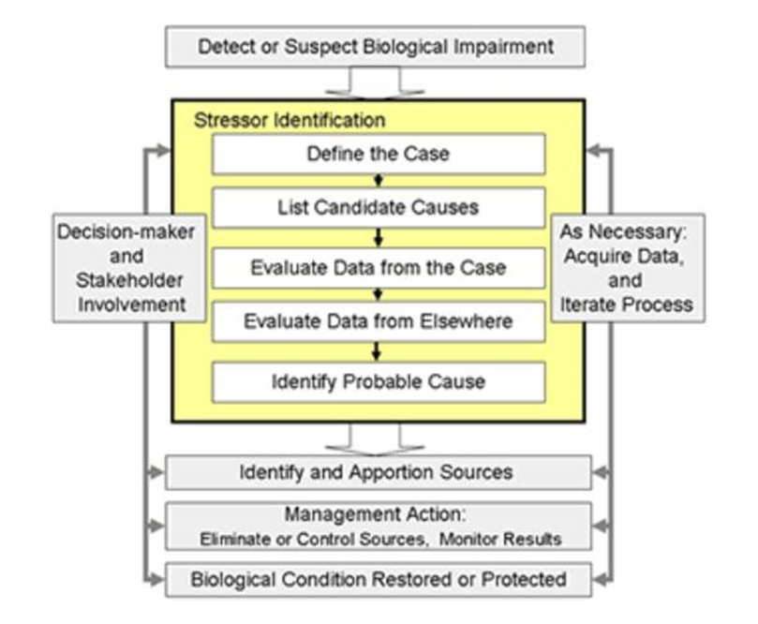
Figure 2. Conceptual model of SID process (Cormier et al. 2000).
Strength of evidence (SOE) analysis is used to evaluate the data for candidate causes of stress to biological communities. The relationship between stressor and biological response are evaluated by considering the degree to which the available evidence supports or weakens the case for a candidate cause. Typically, much of the information used in the SOE analysis is from the study watershed (i.e., data from the case). However, evidence from other case studies and the scientific literature is also used in the SID process (i.e., data from elsewhere).
Developed by the EPA, a standard scoring system is used to tabulate the results of the SOE analysis for the available evidence (Table A1). A narrative description of how the scores were obtained from the evidence should be discussed as well. The SOE table allows for organization of all of the evidence, provides a checklist to ensure each type has been carefully evaluated and offers transparency to the determination process.
The existence of multiple lines of evidence that support or weaken the case for a candidate cause generally increases confidence in the decision for a candidate cause. The scoring scale for evaluating each type of evidence in support of or against a stressor is shown in Table A2. Additionally, confidence in the results depends on the quantity and quality of data available to the SID process. In some cases, additional data collection may be necessary to accurately identify the stressor(s) causing impairment. Additional detail on the various types of evidence and interpretation of findings can be found here: https://www.epa.gov/caddis-vol1/caddis-volume-1-stressor-identification-summary-tables-types-evidence

  - Common stream stressors
The five major elements of a healthy stream system are stream connections, hydrology, stream channel assessment, water chemistry and stream biology. If one or more of the components are unbalanced, the stream ecosystem may fail to function properly and is listed as an impaired water body. Table 1 lists the common stream stressors to biology relative to each of the major stream health categories.
Table 1. Common streams stressors to biology (i.e., fish and macroinvertebrates).
Stream health | Stressor(s) | Link to biology
Stream connections | Loss of connectivity  Dams and culverts  Lack of wooded riparian cover  Lack of naturally connected habitats/ causing fragmented habitats | Fish and macroinvertebrates cannot freely move throughout system. Stream temperatures also become elevated due to lack of shade.
Hydrology | Altered hydrology  Loss of habitat due to channelization  elevated levels of TSS  Channelization  Peak discharge (flashy)  Transport of chemicals | Unstable flow regime within the stream can cause a lack of habitat, unstable stream banks, filling of pools and riffle habitat, and affect the fate and transport of chemicals.
Stream channel assessment | Loss of habitat due to excess sediment  elevated levels of TSS  Loss of dimension/pattern/profile  Bank erosion from instability  Loss of riffles due to accumulation of fine sediment  Increased turbidity and or TSS | Habitat is degraded due to excess sediment moving through system. There is a loss of clean rock substrate from embeddedness of fine material and a loss of intolerant species.
Water chemistry | Low dissolved oxygen concentrations  elevated levels of nutrients  Increased nutrients from human influence  Widely variable DO levels during the daily cycle  Increased algal and or periphyton growth in stream  Increased nonpoint pollution from urban and agricultural practices  Increased point source pollution from urban treatment facilities | There is a loss of intolerant species and a loss of diversity of species, which tends to favor species that can breathe air or survive under low DO conditions. Biology tends to be dominated by a few tolerant species.
Stream biology | Fish and macroinvertebrate communities are affected by all of the above listed stressors | If one or more of the above stressors are affecting the fish and macroinvertebrate community, the IBI scores will not meet expectations and the stream will be listed as impaired.
  - Report format
[Provide a brief overview of how the report is structured. For example, is the information presented in the following sections organized by AUID or by candidate stressors?]
[Example text: “This SID Report follows a format to first summarize candidate causes of stress to the biological communities at the 8-digit HUC scale. Within the summary (Section 3), there is information about how the stressor relates broadly to the [Insert name] Watershed, water quality standards and general effects on biology. Section 4 is organized by impaired AUID (or candidate causes) and discusses the available data and relationship to fish and macroinvertebrate metrics in more detail.”]

- Overview of [Insert Name] Watershed
  - Background
[Provide overview of the watershed: size, basin, ecoregion(s), patterns in land use, major cities and/or geomorphology. The map displayed in Figure 3 should contain elements that highlight unique characteristics of the 8-digit HUC watershed. Additional maps of varying scale can be based on needs of the report and the watershed, but some minimum elements should be presented in Section 2. These minimum required elements are as follows: biologically impaired AUIDS, relevant chemical and biological sampling stations, ground reference points, cities and relative scale to Minnesota. Figures 2.2-2.5 contain examples of maps from existing SID Reports that are applicable for this section. Many options will be possible, so choose figures that best convey the information specific to the watershed and report.]

Subwatersheds
[Insert information on the major subwatersheds or management units that this SID Report is based upon (Example: Figure 4). The following excerpt from the MS River-St Cloud (MR-SC) SID Report provides an example of text that applies to this section: “Due to the sheer size of the watershed and the presence of channelization and reservoirs, it is difficult to evaluate potential stressors to aquatic life without further stratifying the MR-SC drainage into smaller sections. Although there may be some consistent chemical and physical stressors found throughout the MR-SC Watershed, some are likely acting locally, driven by landscape characteristics specific to a certain region of the watershed. For the purpose of addressing biological impairments in the MR-SC, the watershed was stratified in the same 11-digit HUC units used in the MR-SC Monitoring and Assessment Report.”]

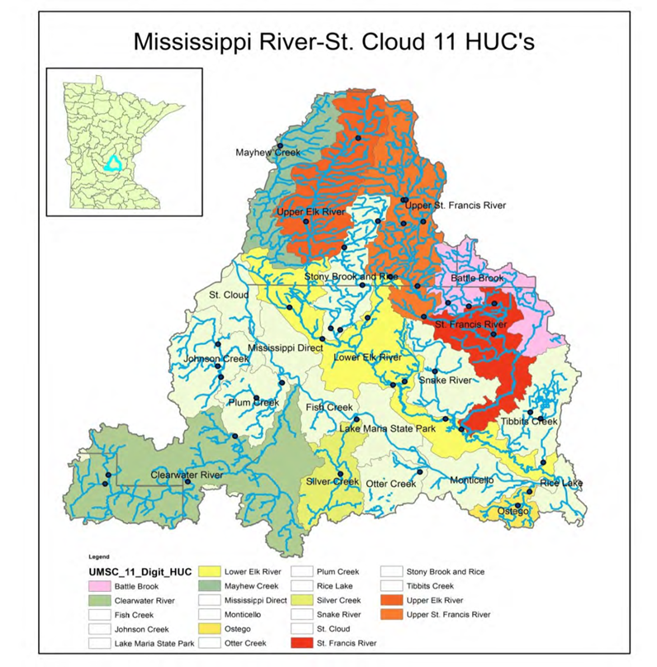
Figure 3. Map showing management units in the [insert name] Watershed. [Multiple options will be possible for figures in this section. Refer to the minimum required elements described in Section 2.1 for guidance. Example: Mississippi River-St Cloud SID Report.]
[Optional: This section also provides an opportunity to discuss variations in the landscape such as land use, geomorphology, agroregions (Example: Figure 5), among subwatersheds.]

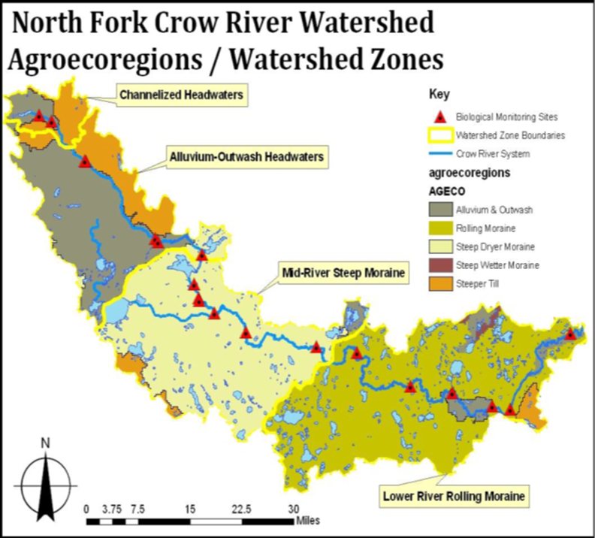
Figure 4. Map of agroregions/watershed zones within the [North Fork Crow River] Watershed. [This example will not be applicable to all SID reports. Multiple options will be possible for figures in this section. Refer to the minimum required elements described in Section 2.1 for guidance.]
  - Monitoring overview
[Include a brief summary of the Monitoring and Assessment status as it relates to the SID process as well as a hyperlink to that report if it’s available. Avoid duplicating too much information presented in the Monitoring and Assessment Report. Example information: beneficial uses that were assessed, chemistry stations, and/or geomorphic study stations. Figure 6 provides an example of the type of figure that can be shown here.]

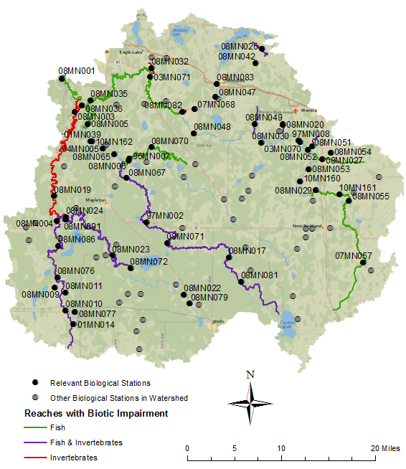
Figure 5. Map of monitoring stations in the [Insert name] Watershed. [Example: Le Sueur River SID Report.]

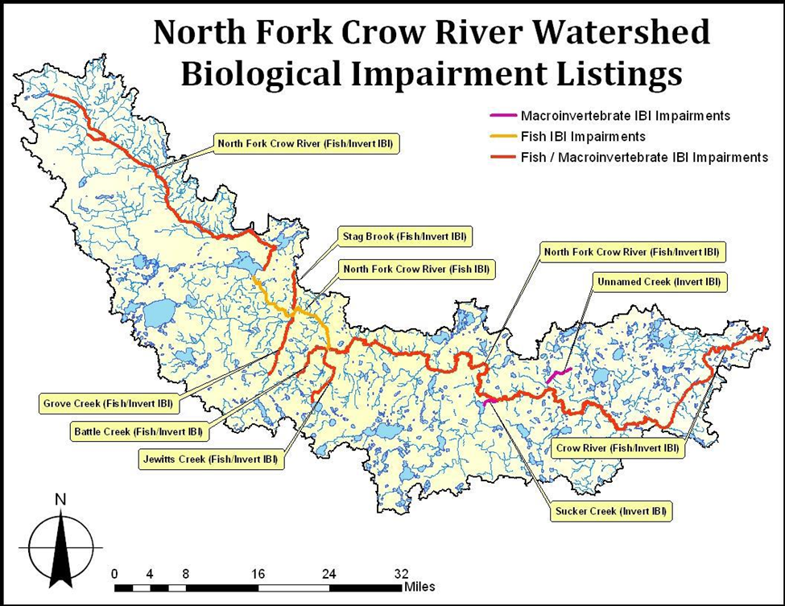
Figure 6. Map of impaired AUIDS in the [Insert name] Watershed. [Multiple options will be possible for figures in this section. Refer to the minimum required elements described in Section 2.1 for guidance.]

  - Summary of biological impairments
The approach used to identify biological impairments includes assessment of fish and aquatic macroinvertebrates communities and related habitat conditions at sites throughout a watershed. The resulting information is used to develop an IBI. The IBI scores can then be compared to range of thresholds.
The fish and macroinvertebrates within each Assessment Unit Identification (AUID) were compared to a regionally developed threshold and confidence interval and utilized a weight of evidence approach [substitute with alternative approach if necessary]. The water quality standards call for the maintenance of a healthy community of aquatic life. IBI scores provide a measurement tool to assess the health of the aquatic communities. IBI scores higher than the impairment threshold indicate that the stream reach supports aquatic life. Conversely, scores below the impairment threshold indicate that the stream reach does not support aquatic life. Confidence limits around the impairment threshold help to ascertain where additional information may be considered to help inform the impairment decision. When IBI scores fall within the confidence interval, interpretation and assessment of the waterbody condition involves consideration of potential stressors, and draws upon additional information regarding water chemistry, physical habitat, and land use, etc.
In the [Insert name] Watershed, [insert # of] AUIDs are currently impaired for a lack of biological assemblage (Table 2).
Table 2. Biologically impaired AUIDs in the [Insert name] Watershed. [Insert additional horizontal lines as needed.]
 |  |  | Impairments
Stream name | AUID # | Reach description | Biological | Water quality
[Tables 3 and 4 are optional. If this information is not included in the SID Report, then the source with that information should be clearly referenced. It is very important to state the specific thresholds and confidence intervals used in the current SID analyses in the event that these numbers change in the future. If the information contained in Tables 3 and 4 are included in the SID Report, then insert a short paragraph describing the assessment process as a weight of evidence approach. {Example: The assessment process is a weight of evidence approach that takes biological response into account along with water chemistry, physical, and exposure indicators when making decisions.} Also state that the explanation for management decisions can be found in the Monitoring and Assessment Report. If new biological stations have been sampled since the Monitoring and Assessment Report was completed, this additional information should be discussed in Section 2.3 and presented in a table and/or text format.]
Table 3. Fish classes with respective IBI thresholds and upper/lower confidence limits (CL) found in the [Insert name] Watershed. [Example: Hawk Creek SID Report]
Class | Class name | IBI thresholds | Upper CL | Lower CL
1 | Southern Rivers | 39 | 50 | 28
2 | Southern Streams | 45 | 54 | 36
3 | Southern Headwaters | 51 | 58 | 44
7 | Low Gradient | 40 | 50 | 30

Table 4. Macroinvertebrate classes with respective IBI thresholds and upper/lower confidence limits (CL) found in the [Insert name] Watershed. [Example: Hawk Creek SID Report]
Class | Class name | IBI thresholds | Upper CL | Lower CL
2 | Prairie Forest Rivers | 30.7 | 41.5 | 19.9
5 | Southern Streams RR | 35.9 | 48.5 | 23.3
7 | Prairie Streams GP | 38.3 | 51.9 | 24.7
The purpose of SID is to interpret the data collected during the biological monitoring and assessment process. Trends in the IBI scores can help to identify causal factors for biological impairments. The macroinvertebrate and fish IBI scores are shown in Table 5. [Insert discussion on trends in IBI scores for macroinvertebrates and fish.]
[Tables 5 and 6 are optional.]
Table 5. Fish and macroinvertebrate IBI scores by biological station within AUID. Key to color coding in Table 6. [Insert additional rows as needed.]
AUID & reach | Station | Year | Fish IBI score* | Fish class | Macroinvertebrate IBI score* | Macroinvertebrate class
Table 6. Key to color coded IBI scores.
≤ lower CL | > lower CL &  ≤ threshold | > threshold &  ≤ upper CL | > upper CL | NA = Not available
[Insert a discussion on IBI metrics and present supporting information tables/figures. Depending on the characteristics of the watershed (e.g.., # of AUIDs or candidate causes), it may be applicable to only discuss trends in IBI scores here with more detailed discussions in Section 4. If applicable, the following is optional: State that the IBI data will be discussed in more detail in Section 4. Include a brief statement here to summarize the information in Table 5 fish and macroinvertebrate IBI scores relative to 8-digit HUC watershed scale.]
  - Hydrological Simulation Program – FORTRAN Model
The Hydrological Simulation Program – FORTRAN (HSPF) is a comprehensive package for simulation of watershed hydrology and water quality for both conventional and toxic organic pollutants. HSPF incorporates watershed-scale Agricultural Runoff Model (ARM) and Non-Point Source (NPS) models into a basin-scale analysis framework that includes fate and transport in one dimensional stream channels. It is the only comprehensive model of watershed hydrology and water quality that allows the integrated simulation of land and soil contaminant runoff processes with in-stream hydraulic and sediment-chemical interactions. The result of this simulation is a time history of the runoff flow rate, sediment load, and nutrient and pesticide concentrations, along with a time history of water quantity and quality at the outlet of any subwatershed. HSPF simulates three sediment types (sand, silt, and clay) in addition to a single organic chemical and transformation products of that chemical.
The HSPF watershed model contains components to address runoff and constituent loading from pervious land surfaces, runoff and constituent loading from impervious land surfaces, and flow of water and transport/transformation of chemical constituents in stream reaches. Primary external forcing is provided by the specification of meteorological time series. The model operates on a lumped basis within subwatersheds. Upland responses within a subwatershed are simulated on a per-acre basis and converted to net loads on linkage to stream reaches within each subwatershed and the upland areas are separated into multiple land use categories.
An HSPF watershed model was run for the [insert name] Watershed to predict water quality condition throughout the watershed on an hourly basis from [year-year] [or other specifics relative to this SID Report]. [Insert statement describing how this model was used and why. For example, minor watersheds with biological impairments used the model output to supplement water quality analyses. Refer to Figure 7 showing a map of the HSPF model numbered subwatersheds. Subwatersheds included in this study are [insert names]. Delete this subsection if HSPF modeling was not conducted in this watershed.]
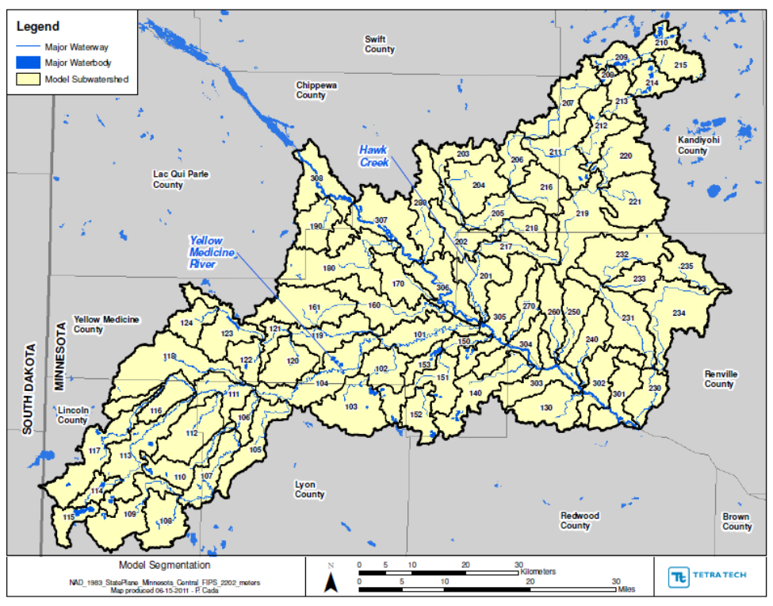
Figure 7. HSPF modeled subwatersheds. [Example: Yellow Medicine River SID Report. Delete if HSPF modeling was not conducted in this watershed.]

- Possible stressors to biological communities
A comprehensive list of potential stressors to aquatic biological communities compiled by the EPA can be found here (https://www.epa.gov/caddis-vol2). This comprehensive list serves two purposes. First, it can serve as a checklist for investigators to consider all possible options for impairment in the watershed of interest. Second, it can be used to identify potential stressors that can be eliminated from further evaluation. In some cases, the data may be inconclusive and limit the ability to confidently determine if a stressor is causing impairment to aquatic life. It is imperative to document if a candidate cause was suspected, but there was not enough information to make a scientific determination of whether or not it is causing harm to aquatic life. In this case, management decisions can include modification of sampling plans and future evaluation of the inconclusive case. Alternatively, there may be enough information to conclude that a candidate cause is not causing biological impairment and therefore can be eliminated. The inconclusive or eliminated causes will be discussed in more detail in the following section.
[Options: Relevant biological metrics data may be presented in Section 3. Insert applicable maps/figures/pictures in the appropriate subsections below.]
  - Eliminated causes
[Provide a brief summary of what causes were eliminated from further evaluation and why. It is very important to do a good job of showing how potential causes are eliminated. Document any notable aspects (e.g., no altered channels in watershed)].
  - Inconclusive causes
[Provide a brief summary of what causes were determined to be inconclusive and why. Document any notable aspects (e.g., not enough data)].
  - Summary of candidate causes in the [Insert name] Watershed
[Insert #] candidate causes were selected as possible drivers of biological impairments in the [insert name] Watershed. [Example: The initial list of candidate/potential causes was narrowed down after the initial data evaluation/data analysis resulting in [insert # of candidate causes] for final analysis in this report.]
Background information specific to candidate causes/stressors in Minnesota can be found here. This information provides an overview of the pathway and effects of each candidate stressor considered in the biological stressor identification process with relevant data and water quality standards specific to Minnesota. The EPA has additional information, conceptual diagrams of sources and causal pathways, and publication references for numerous stressors on its CADDIS website.
    - Overview of [Insert cause (e.g., low dissolved oxygen)] in the [insert name] Watershed
[Insert brief summary of the data trends for this Candidate Cause for the watershed. Present relevant maps, data or pictures to provide an overview of the conditions in watershed related to a particular candidate cause]. Example:
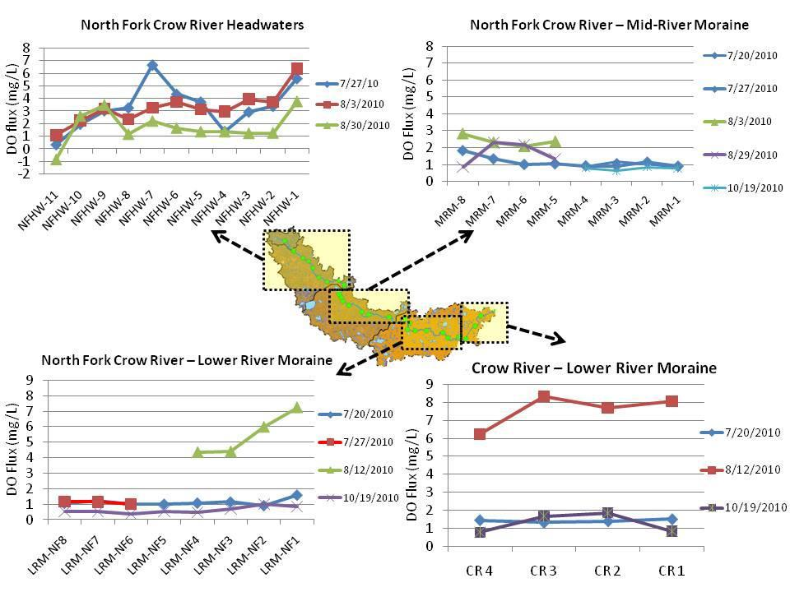
Figure 8. Dissolved oxygen diurnal fluctuation at select North Fork Crow/Crow River sites based on longitudinal (synoptic) monitoring completed in 2010.

Overview of [Repeat sequence for each candidate cause to be discussed] in the [Insert name] Watershed
[For convenience, links to some candidate causes commonly identified in MN SID Investigation are included below]:
Nutrients
Sediments
Flow alteration
Dissolved oxygen
Ammonia
Physical habitat

- Evaluation of candidate causes
[Option #1: Organized by AUID]
[Select Option #1 or #2 depending on the characteristics of the watershed and discussions with MPCA Staff (Note: external contractors need format approval from MPCA Staff). Examples of reports that have been organized by AUID include the Mississippi River-St. Cloud and the Le Sueur River Watershed SID Reports. Delete the information associated with the option not selected. The format for Option #1 is recommended in cases where the following criteria are met:
- Small number of impairments (maximum of 15)
- Land use, chemistry, geomorphology, habitat and hydrology should be another level evaluated for similarities. If not, do not combine; and
- Do not group multiple AUIDs when biological response differs (e.g. biological response of stream AUID A would conclude potential stressor 1 is a stressor; but biological response of stream AUID B would NOT conclude potential stressor 1 is a stressor).]
  - AUID #1
    - Biological communities
[This section will present specifics on the IBI metric analysis and discussion of the analysis. A table or figure showing the metrics data should be presented and discussed here. Discussion elements for Section 4.1.1 should include: Trends in data and discussion of IBI scores/metrics, any relevant discussion of species and abundance for both fish and macroinvertebrate communities, species that dominated a particular site or reach (e.g., fish community was dominated by fathead minnows, significance of groups found.]
    - Data evaluation for each candidate cause
[Example information that must be included in this section: Biological response and chemistry results. Additional relevant information for this section includes: Number of samples collected, time frame of sample collection, value ranges, biological metric relationships with candidate cause.]
    - Stressor pathway
[In this section, briefly describe the mechanisms/pathways for the candidate cause to affect aquatic life. For example, if low dissolved oxygen conditions persist and fish IBI metrics indicated low abundance, discuss how low dissolved oxygen may be a driver for reduced fish abundance. Consider and discuss the mechanisms for low dissolved oxygen (i.e., are excessive nutrients driving an increase in algal abundance and increased decomposition rates resulting in low oxygenated waters?). This section has many options for structure, content, figures, tables and pictures. Choose the organizational level consistent with how the report is structured (i.e., by AUID or candidate cause.]
    - Strength of evidence
[Refer to the SOE table(s) in the Appendix. Discuss the findings that support or weaken the causal pathway for a candidate cause. Avoid just simply referring to the weight of evidence tables in the Appendix without discussion.]

    - AUID summary
[Provide a brief summary of the overall findings for a particular AUID. Options may include additional or more thorough discussion inconclusive causes and needs for additional sampling, synthesis of the multiple lines of evidence to support or refute causes, etc.]
  - AUID #2 [repeat sequence]
  - Identification of probable causes
[Provide a description of the probable causes of stress to aquatic life.]
  - Conclusion
[In this section, provide an overall conclusion for all AUIDs discussed in the previous subsections. This is an opportunity to connect the findings discussed for each AUID. Mention recommendations for monitoring, restoration priorities and TMDL recommendations. Optional: It may be helpful to provide a summary or a table classifying the candidate causes as eliminated, inconclusive or probable.]

- Evaluation of candidate causes
[Option #2: Organized by candidate causes]
[Select Option #1 or #2 depending on the characteristics of the watershed and discussions with MPCA Staff (external contractors need approval on format from MPCA Staff). An example report that is organized by candidate causes is the Yellow Medicine River Watershed SID Report. Delete the information associated with the option not selected. The format for Option #2 is recommended in cases where the following criteria are met:
- Biological response must be similar when combined (similar patterns in IBI metrics for impaired assemblages. Do not combine if there are different biological responses.
- Land use, chemistry, geomorphology, habitat and hydrology should be another level evaluated for similarities. If not, do not combine.
- Good option for watersheds with large numbers of impairments, particularly small tributaries.]
  - Candidate cause #1 (e.g., High phosphorus)
    - Biological communities
[This section will present specifics on the IBI metric analysis and discussion of the analysis. A table or figure showing the metrics data should be presented and discussed here. Discussion elements for Section 4.1.1 should include: Trends in data and discussion of IBI scores/ metrics, any necessary discussion of species and abundance for both fish and macroinvertebrate communities, species that dominated a particular site or reach (e.g., fish community was dominated by fathead minnows, significance of groups found.]
    - Data evaluation for each AUID
[Example information that must be included in this section: Biological response and chemistry results. Additional relevant information for this section includes: Number of samples collected, time frame of sample collection, value ranges, biological metric relationships with candidate cause.]
    - Stressor pathway
[In this section, describe how the candidate cause may affect aquatic life. For example, discuss how low dissolved oxygen may be a driver for reduced fish abundance. Consider and discuss the mechanisms for low dissolved oxygen (i.e., are excessive nutrients driving an increase in algal abundance and increased decomposition rates resulting in low oxygenated waters?). This section has many options for structure, content, figures, tables and pictures. Choose the organizational level consistent with how the report is structured (i.e., by AUID or candidate cause).]
    - Strength of evidence
[Refer to the SOE table(s) in the Appendix. Discuss the findings that support or weaken the causal pathway for a candidate cause. Avoid just simply referring to the weight of evidence tables in the Appendix without discussion.]
    - Candidate cause summary
[Provide a brief summary of the overall findings. Options may include additional or more thorough discussion inconclusive causes and needs for additional sampling, synthesis of the multiple lines of evidence to support or refute causes.]
  - Candidate cause #2 [repeat sequence]
  - Identification of probable causes
  - Conclusion
[Discuss overall conclusion for candidate causes in the watershed. Mention recommendations for monitoring, restoration priorities and TMDL recommendations. Optional: It may be helpful to provide a summary or a table classifying the candidate causes as eliminated, inconclusive or probable.]

- Conclusions and recommendations
  - Summary of probable stressors
[Insert brief summary of probable stressors that were determined to be causing stress to the biological communities in the watershed. Refer to Table 7, which should be organized using the same structure as report. Examples are provided below and can be easily edited to fit the needs of the report.]
Table 7. Summary of probable stressors in the [Insert name] Watershed. [Insert additional rows as needed.]
Stream name | AUID | Biological impairment | Stressors
Stream name | AUID | Biological impairment | Low DO | High phosphorus | High turbidity/TSS | Altered hydrology | Lack of habitat
 |  | [Fish, Macroinvertebrates or both]
● = probable stressor; o = inconclusive stressor
  - Recommendations
[Provide summary of recommendations – structure and content is optional depending upon SID Report structure. Recommended prioritization of TMDL may include brief reference to Table 8 (which is optional) along with any other management recommendations identified in the SID process. This is a good place to discuss additional monitoring efforts if necessary.]
[Optional: this may also be a good place to include information on Protection. Are there places of special biological integrity that should be called out in the watershed, and also are there places that are not currently impaired, but may be on the verge if impairment?]
Table 8. Recommended prioritization of TMDLs relative to the stressors contributing to the biological impairment in the [Insert name] Watershed. [Example: Ann River SID Report]
Stressor | Priority | Comment
Sedimentation | High | TMDL should focus on reducing sediment input from riparian corridor (cattle pastures) and immediate stream channel (stream banks).
Riparian disturbance | High | TMDL should aim to re-establish quality riparian corridor to increase woody debris, CPOM inputs, and stream shading.
Flow alteration | Unknown | The impact of impoundments on the flow regime is difficult to determine given the lack of flow data before the impoundments were installed.
Low DO | Medium | Additional data collection summer 2010 to verify low DO conditions. DO should be treated as a secondary stressor.

- References
[Insert alphabetized list of references used in the document]
Cormier S., S. Norton, G. Suter and D. Reed-Judkins. 2000. Stressor identification guidance document. U.S. Environmental Protection Agency, Washington D.C., EPA/822/B-00/025.
http://water.epa.gov/scitech/swguidance/standards/criteria/aqlife/biocriteria/upload/stressorid.pdf
Minnesota Pollution Control Agency (MPCA). 2008. Draft Biota TMDL Protocols and Submittal Requirements. Minnesota Pollution Control Agency, St. Paul, Minnesota. http://www.pca.state.mn.us/index.php/view-document.html?gid=8524
U.S. EPA. 2010. Causal Analysis/Diagnosis Decision Information System (CADDIS). Environmental Protection Agency. Office of Research and Development, Washington, DC. Available online at http://www.epa.gov/caddis.

- Appendix
[Tables presented below are required to be in the Appendix in some fashion. Additional figures/tables/maps can be included as needed. It is optional to develop one appendix or have multiple appendices, but they should be clearly labeled and referenced appropriately. Be sure to reference the tables/figures in the text. The order of displayed tables in the Appendix should appear in the same order as they are referenced in the main body of the report.]
Table A1. Values used to score evidence in the SID process. [Example: MS River/Lake Pepin SID Report].
Table A2. Strength of evidence scores for various types of evidence. [Example: MS River – Lake Pepin SID Report].

Table A3. Biological metrics included in the SID process. [This table must be shown in the SID Report until it is published elsewhere, at which point, it can then be referenced through a hyperlink. Table A3 must be referenced in the main body of the report. Example: MS River-Lake Pepin SID].
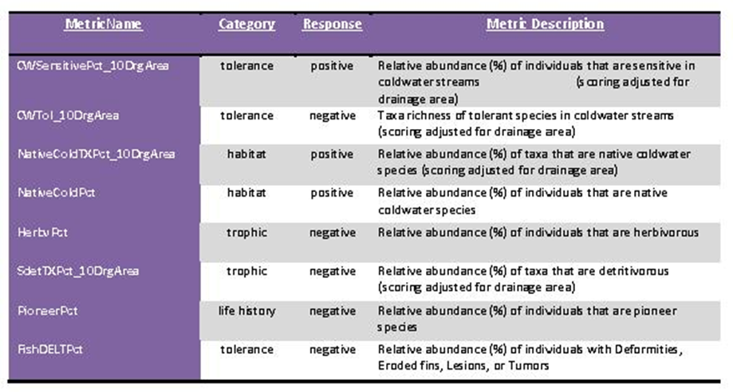

Table A4. Strength of evidence table for candidate causes. [This table could take many forms – a single table for all causes evaluated or multiple tables – chosen format is optional, but it should mimic the organizational structure of Section 4 for consistency. Example: Yellow Medicine River.]

Table A5. Summary of biological assessments. [Only show this table if it contains new info since Monitoring and Assessment Report. Example: MS River – Lake Pepin SID Report.]
