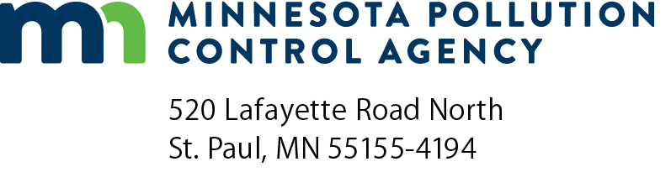 | Exclusion application  Exclusion from Phosphorus Limit, PIP and Annual Compliance Report  Minnesota River Basin General Phosphorus Permit – Phase I  Doc Type: Permit Application

Instructions: MNG42 permittees should submit this form to the address listed below by April 30 annually if they qualify for an exclusion based upon the criteria identified below.
Any facility listed in Appendix B of the Minnesota River Basin General Phosphorus Permit – Phase I (Basin Permit) as of the date of issuance (i.e., December 1, 2005) is eligible to apply for an exclusion from their 5-Month Mass Phosphorus Limit, Pre-season Implementation Plan (PIP) and Annual Compliance Report requirements (Requirements) of the Basin Permit, provided they meet the conditions established in Chapter 5, subpart 2 of the Basin Permit.
The following are the two types of exclusion allowed by the Basin Permit:
A. Compliance Agreement – Permittees who have executed a compliance agreement with the MPCA by April 1, 2008, which requires a 1.0 mg/L phosphorus limit in their individual NPDES/SDS permit prior to expiration of this Basin Permit are excluded from the Requirements of this Basin Permit (identified above); and
B. Annual Exclusion – Permittees with a 1.0 mg/L phosphorus limit listed in their individual NPDES/SDS permit which are not participating in pollutant trading and have submitted a completed Exclusion Application Form to the MPCA Commissioner by April 30 of a calendar year are excluded from the Requirements (identified above) during that calendar year.
Permittees who qualify for and have submitted an exclusion application are still subject to all other applicable permit requirements of both their individual NPDES/SDS permit as well as the requirements of the Basin Permit. To apply for this exclusion, complete this Exclusion Application Form and submit it to the following address: WQ Submittal Center, Minnesota Pollution Control Agency, 520 Lafayette Road North, St. Paul, MN 55155-4194.

Permittee information
Permittee name: |  |  | MN River Basin Permit No.: MNG4200
Type of exclusion (choose one): |  | Compliance agreement Annual exclusion |  | Year (yyyy): | 20

Certification and signature
I certify under penalty of law that this document and any attachments were prepared under my direction or supervision in accordance with a system designed to assure that qualified personnel properly gathered and evaluated the information submitted. Based on my inquiry of the person, or persons, who manage the system, or those persons directly responsible for gathering the information, the information is, to the best of my knowledge and belief, true, accurate, and complete. I am aware that there are significant penalties for submitting false information, including the possibility of fine and imprisonment. I hereby apply for an exclusion from this facility’s 5-Month Mass Phosphorus Limit, Pre-season Implementation Plan and Annual Compliance Report under the terms and conditions of the Minnesota River Basin General Phosphorus Permit – Phase I. I am aware that this exclusion does not apply to any requirements listed in my facility’s individual NPDES/SDS permit or any other applicable permit.
By typing/signing my name below, I certify the above statements to be true and correct, to the best of my knowledge, and that this information can be used for the purpose of processing this form.
Authorized Representative
Signature: |  | Title:
 | (This document has been electronically signed.) | Date (mm/dd/yyyy):

