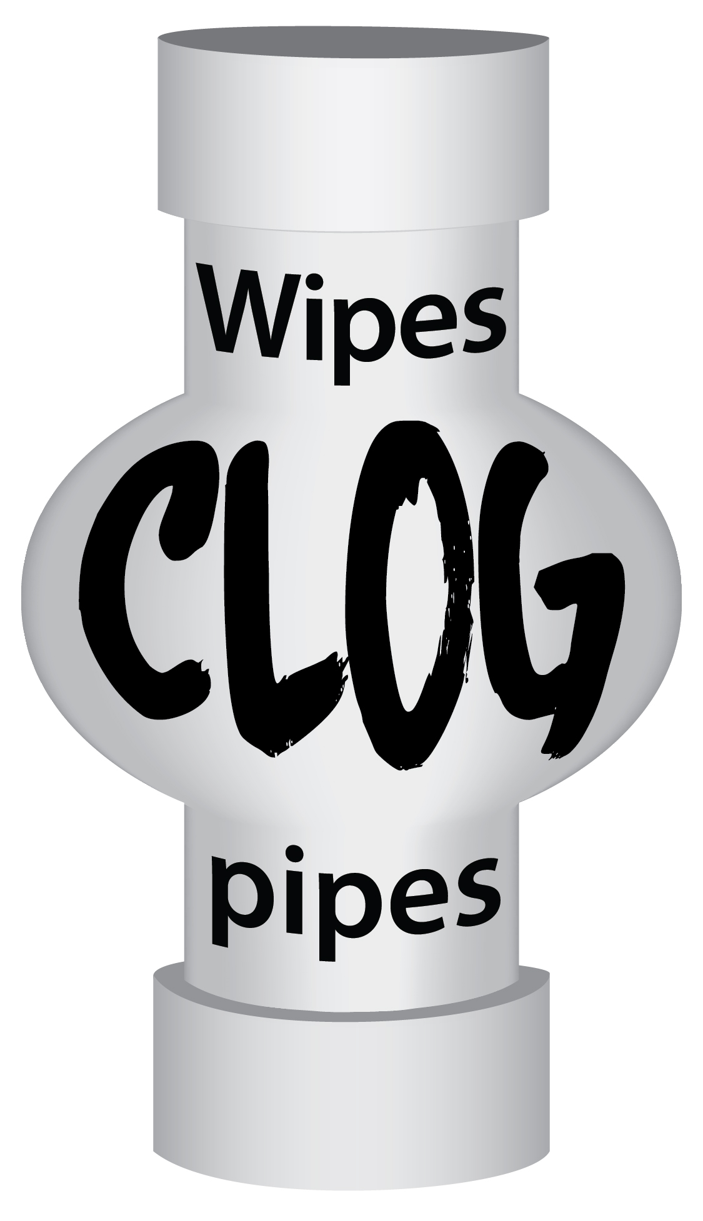

Even if they say “flushable,”
disposable wipes will clog pipes

Prevent costly backups and place wipes in trash

INSERT CITY LOGO AND WEBSITE ADDRESS

