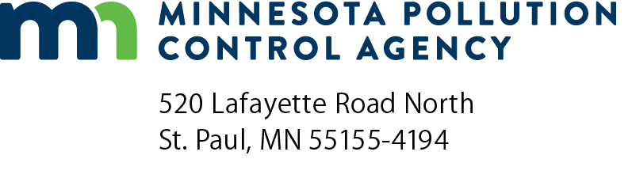 | Wastewater and biosolids  training manuals order form  Training and Certification  Doc Type: Training Materials
Instructions: Enter in the number of manuals you are requesting in the quantity column, and enter the sub-total(s) in the amount column and total. Send your completed order form and a check for the total amount made out to the Minnesota Pollution Control Agency. (Credit cards are not accepted.) The publications will be mailed upon receipt of payment. If you have any questions, please contact Christi Torgusson at 651-757-2482.
Send order and payment to: Minnesota Pollution Control Agency (MPCA)
Fiscal Services – 6th Floor
520 Lafayette Road North
St. Paul, MN 55155
Order information
Quantity | Description | Unit price | Amount
 | Collection System Basic Manual | $20.00 | $
 | Collection System Math Workbook and Formula Book | $13.00 | $
 | Wastewater Treatment Technology | $20.00 | $
 | Wastewater Math Workbook and Formula Book | $13.00 | $
 | Wastewater Glossary | $10.00 | $
 | Stabilization Pond | $20.00 | $
 | Land Application of Biosolids – 2001 Edition | $20.00 | $
 | Biological Nutrient Removal | $15.00 | $
Total: |  |  | $

Mailing information (type or print legibly)
 | Full name:
 | Mailing address:
 | City: |  |  |  |  | State: |  | Zip code:
 | Phone:

MPCA Use Only

Invoice
Invoice date (mm/dd/yyyy): |  |  | Payment date (mm/dd/yyyy):

Deposit # 2000/R3280000/R32C112/5113304/6709

