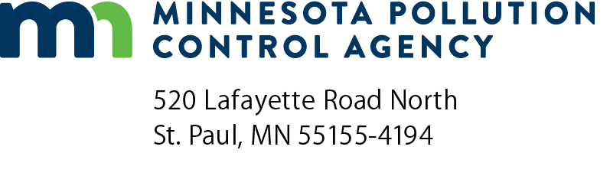 | Drinking Water Planning and Design Funds for PFAS Treatment  Grant Application  Doc Type: Application

Instructions: Please read the complete Drinking Water Planning and Design Funds for PFAS Treatment Request for Proposal (RFP) and other associated documents before submitting this application.
Submit application to: grants.pca@state.mn.us with the subject line, “Drinking Water PFAS Treatment Planning Application.” Applications will be accepted until all dedicated funds have been awarded or 4:00 pm Central Time on Friday, June 28, 2024, whichever occurs first.
Eligibility: In order to be eligible for the Drinking Water Planning and Design Funds for Per- and polyfluoroalkyl Substances (PFAS) Treatment program, an applicant must meet all of the following criteria:
- Eligible applicants include owners or operators of community water systems in Minnesota.
- Eligible applicants must have a minimum of four quarters of samples taken from entry points. Preferred analytical methods are Environmental Protection Agency (EPA) methods 533 or 537.1.
- Eligible applicants must have a four-quarter rolling average that exceeds the EPA Final maximum contaminant level (MCL) values of 4 parts per trillion (ppt) for Perfluorooctanesulfonic acid (PFOS) or Perfluorooctanoic acid (PFOA) or 10 ppt for Hexafluoropropylene oxide dimer acid (HFPO-DA or GenX), perfluorononanoic acid (PFNA), or Perfluorohexane sulfonic acid (PFHxS) or exceeds the Hazard Index MCL of 1.0 for Perfluorobutane sulfonic acid (PFBS), Hexafluoropropylene oxide dimer acid (HFPO-DA or GenX), perfluorononanoic acid (PFNA), or Perfluorohexane sulfonic acid (PFHxS).
- Eligible projects include planning and designing of treatment systems to address PFAS contamination for community water systems.
- Not be currently eligible for the Minnesota 3M PFAS Settlement.
Project information
Organization name:
Organization address: |  |  |  |  |  |  |  | County:
City: |  |  |  |  |  | State: |  | Zip:
Contact name: |  |  |  |  |  | Title:
Phone: |  |  |  |  | Email address:

Grant amount requested: | $

Are you the owner or operator of a community water system in Minnesota?
Yes No
Does your organization have a minimum of four quarters of samples taken from entry points for the contaminants that exceed the MCLs? Preferred data is from EPA methods 533 or 537.1. If your data is from an older method with higher reporting limits, the results must be above the reporting limit to be considered.
Yes No
Please list the analytical method used for the four quarters of samples used to determine exceedance of the MCL:
Does your organization have a four-quarter rolling average that exceeds the EPA Final MCL values of 4 ppt for PFOS or PFOA or 10 ppt for PFNA, PFHxS, GenX or exceeds the Hazard Index MCL of 1.0 for PFNA, PFHxS, GenX and PFBS?
Yes No
Does your project include planning and designing of treatment systems to address PFAS contamination for community water systems?
Yes No
Are you currently eligible for the Minnesota 3M PFAS Settlement?
Yes No

Describe the proposed project below:
Below, provide the estimated design flow rate in million gallons per day (MGD) and/or gallons per minute (gpm), not to exceed reasonable demand estimates up to the year 2040. If estimated design flow rate is unknown, please provide current flow rates.
MGD:
gpm:
Project budget

Include your estimated costs below or attach an additional sheet if necessary.

