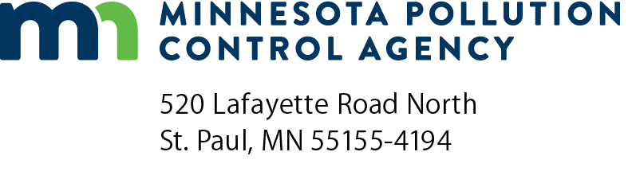 | Dry cleaner cost share grant -  Rolling application  Dry cleaner cost share for PERC alternatives  FY2022-2024  Doc Type: Grant Application
Instructions: Please read the complete Dry cleaner cost share for Perchloroethylene (PERC) alternatives request for proposal (RFP) before submitting this application.
Submit application to grants.pca@state.mn.us with the subject line: Dry Cleaner Cost Share Rolling Application.
Applications will be accepted until until all dedicated funds have been dispersed or 4:00 p.m. Central time on Wednesday, January 31, 2024, whichever occurs first. Projects must be completed by April 30, 2024 to be eligible for reimbursement.
Applicant information
Organization name:
Organization address (where the PERC replacement will be carried out):
City: |  |  |  |  | State: |  |  | Zip code: |  |  |  |  | County:
Contact name: |  |  |  |  |  |  |  |  |  |  |  | Title:
Phone: |  |  |  |  |  | Email address:
Grant information
Grant amount requested: | $ | + | Matching funds: | $ |  | = | Total project cost: |  | $
Provide an estimated amount of PERC used annually (gallons):
Describe your proposed project, including the type of equipment currently used, the proposed replacement equipment, and project timeline:

