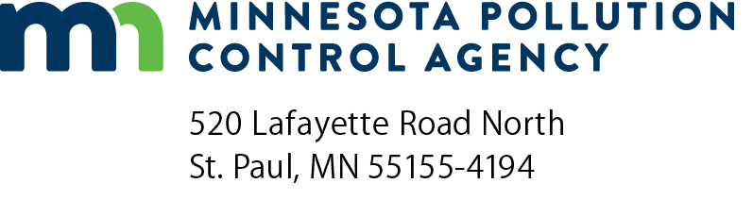 | Subcontractor Construction  Purchase Order Form  Construction projects up to $50,000 for MPCA Contracts  Section 3  Doc Type: Contract
This form to be used by the Minnesota Pollution Control Agency (MPCA) Contractor when hiring a Construction Contractor only.
Contract title: |  |  |  |  | Contract number:
MPCA purchase order number: |  |  | Project Name:
Subcontractor information
Subcontractor name:
Address:
City: |  |  |  |  |  |  | State: |  |  | Zip code:
Contact name: |  |  |  |  | Phone: |  |  |  | Vendor quote no.:
Supplemental terms
1. | Show the Contract number on invoice and all correspondence.
2. | This MPCA Subcontractor Construction Purchase Order Form incorporates by reference all terms, conditions, and specifications of the solicitation and vendor’s response. In case of a conflict in terms, the order of precedence shall be: First; this MPCA Subcontractor Construction Purchase Order Form, second; the Request for Bid (RFB), third; the vendor’s response.
3. | All deliveries/services hereunder shall comply with all applicable state of Minnesota and federal laws.
4. | Invoices must match line items on the MPCA Subcontractor Construction Purchase Order Form.
5. | Notwithstanding any language to the contrary herein, the Contractor, |  |  |  | shall be solely
 | responsible for the payment of the amounts payable by the state of Minnesota under this MPCA Subcontractor Construction
 | Purchase Order Form, as provided in MPCA Contract No. |  |  | The MPCA Contractor’s responsibility under
 | this MPCA Subcontractor Construction Purchase Order Form is to make payments of amounts due hereunder, and as provided in requests for payment submitted and approved by the State.
Ship to information
Name:
Address:
City: |  |  |  |  |  |  |  |  | State: |  |  |  | Zip code:
Contact name: |  |  |  |  |  | Phone: |  |  |  |  |  | Discount terms:
Ship via: |  |  |  |  | Freight terms: |  |  |  |  |  | Requested delivery:
Bill to information
Name:
Address:
City: |  |  |  |  |  | State: |  |  | Zip code:
Contact name: |  |  |  |  | Phone:

Line | Description | Quantity | Unit | Unit price | Amount
Order total
(Payment. The Contractor shall provide an IC 134 – Withholding Affidavit for Contractor to the State agency along with the request for final payment/ invoice. Submit Excel Prevailing Wage Payroll Information Forms to the following email address: prevailingwage.pca@state.mn.us.)
Signature:
 | (This document has been electronically signed.)
MPCA Contractor name: |  |  | Date (mm/dd/yyyy):
MPCA Contract number: |  |  | Purchase order number:

