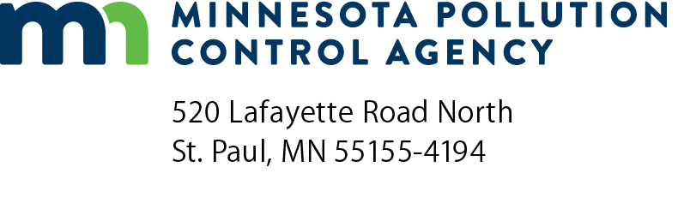 | 115E Prevention and Response Plan  Submittal form for unit trains  Emergency Response  Doc Type: Plans
This form must accompany Prevention and Response Plans (PRP) submitted by railroads operating unit trains, as required under Minnesota Statute 115E.042 Subd. 6.
Plan contact information
Railroad company:
Company contact name: |  |  |  | Phone:
Email:
Additional Plans
This plan is for rolling stock only.
This plan is for rolling stock and other company facilities regulated by Minn. Stat. 115E.

Please list facilities included:
Security Sensitive Information (SSI)
Plan(s) that contain Security Sensitive Information (SSI) must follow federal requirements and must submit an additional copy with SSI redacted and the plan marked “Public.”
Plan Contents
Submitted plans must contain all applicable components identified in Minnesota Statute 115E. It is recommended to include a regulatory “cross-walk” that identifies where in the plan the various components of are addressed.

Name of person submitting plan: |  |  |  | Title:
Company: |  |  |  | Phone:
Email: |  |  |  | Date (mm/dd/yyyy):

