 | Qualitative information: Instructions  AERA-02b  Air Emissions Risk Analysis (AERA)  Doc Type: Air Emissions Risk Assessment – External Documentation
Proposer/Preparer instructions for AERA Form-02

Boxes can be checked by clicking on them. Response areas will expand as necessary to include the complete response. Multiple dates can be added by using the “Enter key” (return key) after you type the first date. All Air Emission Risk Analysis (AERA) documents must be submitted electronically whether submitted with an air permit application or alone. AERA documents submitted with an air permit application must also be submitted in a hard copy. Hard copies of spreadsheets, like the Risk Assessment Screening Spreadsheet (RASS) and lengthy modeling files should include the first summary page of the document but do not need to include subsequent pages since the electronic version will be available for review.

If all of the requested forms and support documents are not included with an air permit application needing an AERA the air permit application will be deemed incomplete. This includes risk estimates for pre-existing facilities. Minnesota Pollution Control Agency (MPCA) staff will return this AERA form plus any other incomplete AERA forms to the applicant with deficiencies and remedies indicated in the italicized MPCA review areas. If forms were submitted pre-app they should be updated and re-submitted post-app with any italicized MPCA comments left in and changes summarized in the appropriate areas.
Facility information: Fill in the TEMPO AI No. (Number), Standard Industrial Classification (SIC) code, facility name and location, and submittal dates. The project proposer and AERA preparer should be people that MPCA staff can contact with general and technical questions about the AERA submittal.
Maps
Maps provide a pictorial representation of information and allow for significant abbreviation of text submittals. Each map should be standardized with a title, reference, date, legend, scale, north arrow, and occasionally a radius. Additional information can be added to clarify the maps or facility surroundings. It is recommended to verify information with a site visit.
Access to qualitative information form: The AERA-02 Qualitative information form can be accessed on the MPCA’s AERA Qualitative webpage at https://www.pca.state.mn.us/business-with-us/air-emissions-risk-analysis-aera. A quick reference table is located at the end of the document that provides some examples on where to get the qualitative information.
Buffer distances
Buffer distances based on stack height are used to determine appropriate distances for evaluating qualitative information about the setting of an emissions source. Incremental ambient air concentrations and risk estimate from an emissions source occur within a distance that depends upon stack height (among other factors). As a rule of thumb, the greater the stack height, the greater the distance to the maximum pollutant concentration, deposition, and risk estimate. The buffer distances are judgments of areas around an emission source that will encompass most emissions of concern and are based on MPCA staff’s experience in estimating pollutant concentrations and deposition fluxes. For the purposes of AERA guidance, the MPCA recommends the following buffer distances for maps showing sensitive receptors, general neighborhood information, and nearby permitted air emission facilities:
- Stack height less than 50 meters: 1.5 kilometers (approximately one mile) radius
- Stack height between 50 and 100 meters: 3 kilometers (approximately two miles) radius
- Stack height greater than 100 meters: 10 kilometers (approximately six miles) radius
Zoning and land use maps should be based on a 10-kilometer radius regardless of stack height. If zoning or land use information exists for a city, township, or county that does not specifically include the 10-kilometer radius surrounding the facility, this information may be considered inadequate. The MPCA recognizes that some areas of the state do not have specific zoning information available.
For facilities with stack heights less than 100 meters, a map should be provided showing lakes, rivers, and streams within a 3 km radius (approximately 2 miles). For facilities with stack heights greater than 100 meters, show lakes, rivers, and streams for the area within a 10 km radius (6 miles). Also, show water bodies outside the specified area that may be fed by rivers and streams lying within the radius of interest.
1. Sensitive receptors
Provide a map with appropriate radius around the facility and the surrounding area that identifies receptors or areas with individuals that may be particularly susceptible to potential chemical exposures. These may include schools, daycare facilities, public recreation areas (e.g., playgrounds, swimming pools, tennis courts, city parks, etc.), nursing homes, and hospitals (among other areas) where sensitive groups may congregate. Also provide the location and distance of the facility to the nearest resident(s). An example of a sensitive receptor map is found below. Google Maps© may also be used to determine distance to sensitive receptors such as schools and parks.
A list may also be provided that includes the names and distances to the sensitive receptors.
Consider notifying local residents and community members about your project. Early communication efforts are useful in establishing a good relationship with neighbors and in learning community concerns in advance of the public notice period.
Sensitive receptor map example
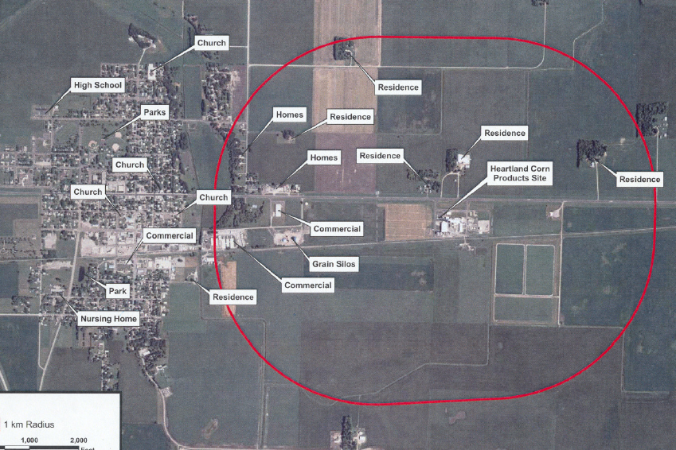
Provided by Natural Resources Group, Inc. for the purposes of an AERA submittal
2. General neighborhood information
Provide census and demographic information such as the population of the nearest town or neighborhood. This information may be provided using general descriptions and lists. Maps may be used to clarify available information.
Population density map example (from internal GIS system)

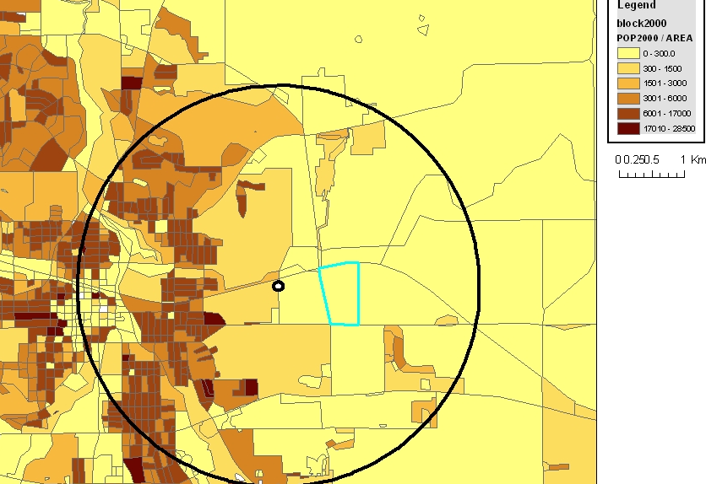

Map created by MPCA for purposes of an AERA
3. Nearby permitted air emission facilities
Using MPCA’s Environmental Data Access webpage, a project proposer can generate a map showing point source emissions or air quality monitors. On the Environmental Data webpage, click on the data you would like to search, such as point sources of pollution. On the pop-up window, click “search using a map” on the bottom left of the box.

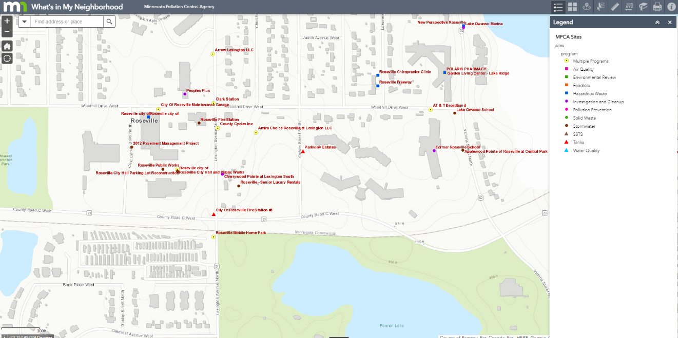

Provide a map and/or list of permitted air emission facilities and sources within proper radius of the facility. After drawing a radius, MPCA’s “What’s in My Neighborhood” website will provide a list of facilities within that radius. Note: The user must zoom in close enough to see the facilities on the screen.
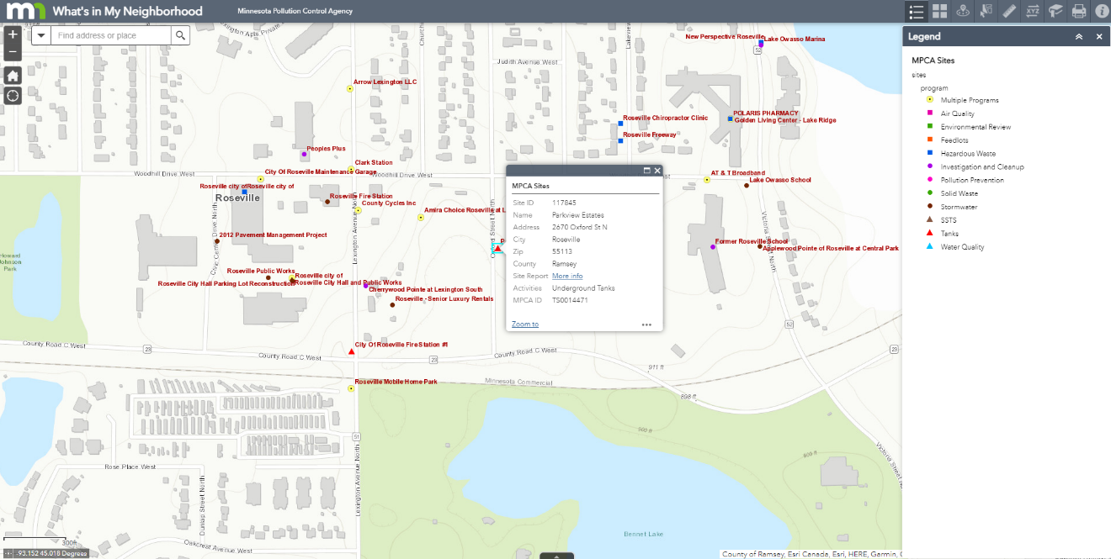
4. Zoning
If available, provide a map and/or description of zoning, centered at the facility centroid, extending out to at least 10 kilometers of the facility (or of the relevant county, city, or township(s)). You may want to supplement maps with relevant ordinances that would inform potential exposures, (e.g., raising chickens in town or prohibitions of livestock, etc.). If this information is not provided, the MPCA cannot make assumptions regarding zoning restrictions.
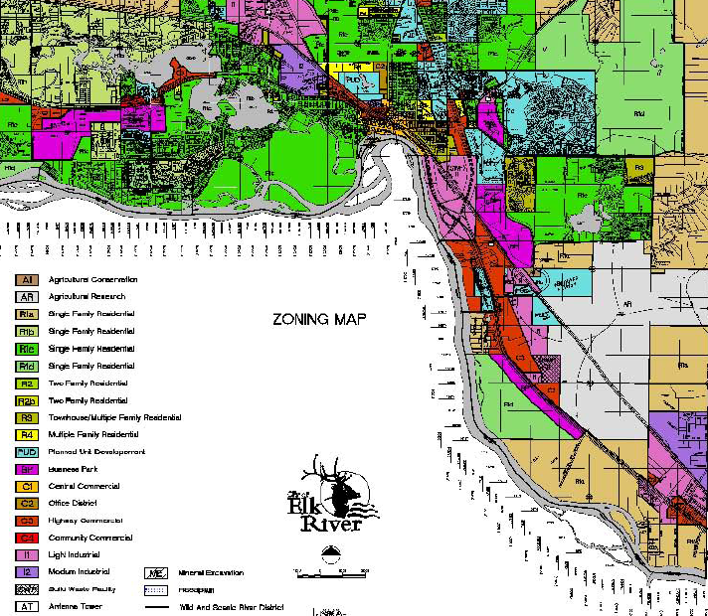

Map provided to MPCA by BARR and created by WENCK for the purposes of an AERA and EAW
5. Land use
Provide a map showing current land use, centered at the facility centroid, extending out to at least 10 kilometers of the facility. Land use maps include information such as areas of residential, commercial and industrial use, farms, forests, and waterways. If no map is provided, the most restrictive land use will be assumed. The proposer should also state whether the land is used for other purposes than those designated on the land use maps. The MPCA considers “reasonable potential future land use” when evaluating potential impacts to nearby property. Definitions for “reasonable potential future land use” come from U.S. Environmental Protection Agency’s (EPA) Human Health Risk Assessment Protocol for Hazardous Waste Combustion Facilities (HHRAP). Further information can be found on the MPCA’s website at https://www.pca.state.mn.us/business-with-us/air-emissions-risk-analysis-aera.
Zoning and land use map example
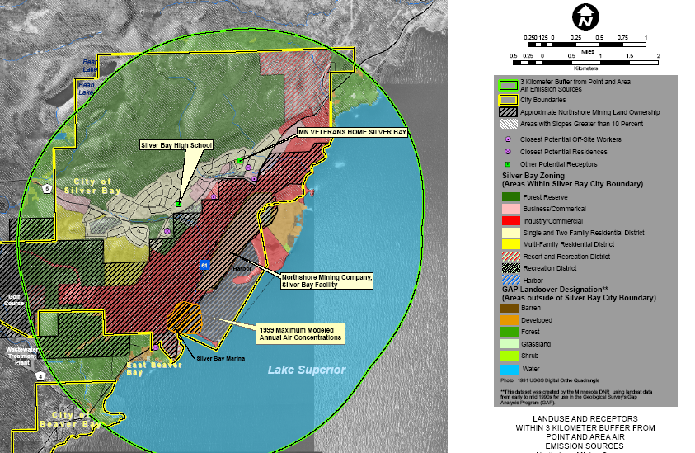
Mining Company
Map created by Barr Engineering for purposes of AERA submittal.
6. Risk isopleths
If conducting a refined risk assessment using the Emission Rate/Chemical Health Index (Q/CHI) process or a receptor grid-based HHRAP type multipathway analysis, a project proposer can use American Meteorologic Society/Environmental Protection Agency Regulatory Model (AERMOD) to generate risk isopleth maps. Locations of all receptors should be noted on the map. Please only submit isopleths maps for risk results above 0.1 (0.1 in 100,000 for cancer estimates).

Persistent bioaccumulative toxic chemicals (PBTs)

Facilities emitting PBTs should provide a map showing the following features:
- Fishable water bodies
A water body may be considered “fishable” if it typically contains water year-round in a year that receives at least 75 percent of the normal annual precipitation for that area. Provide a map showing lakes, rivers and streams within the appropriate radius depending on stack height. Also, show water bodies outside the specified area that may be fed by rivers and streams lying within the radius of interest. It is also useful to know there is public access to the water.
- Farming locations
While land use maps provide the Agency with general information, it is recognized that agricultural land use does not equate to actually having farms present. Provide a map showing the specific locations of farms within the specified area.
If no information is available regarding land use, the default assumption will be that a farmer could be impacted by facility emissions, and the farmer’s risks will be used as a basis for decisions. If land use indicates that farms do not exist within the appropriate radius, only resident risks will be assessed. Resident exposures could include ingesting chickens, eggs, or other livestock that are raised on the property.
Recommended exposure scenarios
Exposure pathways | Recommended exposure scenariosª
Exposure pathways | Farmer | Resident | Fisher
Inhalation of vapors and particles | * | * | *
Incidental ingestion of soil | * | * | *
Ingestion of drinking water from surface water sources | * | * | *
Ingestion of homegrown produce | * | * | *
Ingestion of homegrown beef | * | -- | --
Ingestion of milk from homegrown cows | * | -- | --
Ingestion of homegrown chicken | * | b | b
Ingestion of eggs from homegrown chickens | * | b | b
Ingestion of homegrown pork | * | -- | --
Ingestion of fish | b | b | *
Notes:
* Pathway is included in exposure scenario.
-- Pathway is not included in exposure scenario.
a Exposure scenarios are defined as a combination of exposure pathways evaluated for a receptor at a specific location.
b Site-specific exposure setting characteristics (e.g., presence of ponds on farms, or presence of ponds or small livestock within semi-rural residential areas) warrants the permitting authority to consider adding this exposure pathway to the scenario.

