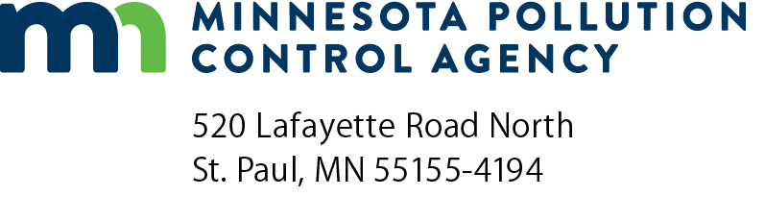 | MGCR-04  Part 70 Manufacturing General Permit  Annual compliance certification report  Air Quality Permit Program  Doc Type: Compliance Certification
Instructions: Refer to the Handbook and Application Instructions for the Part 70 Manufacturing General Permit for form instructions. Sign this form, then create a PDF copy and email to: AQRoutineReport.PCA@state.mn.us.
For more information visit the Air permit compliance forms webpage.

a) AQ Permit number: |  |  | b) Agency Interest ID number:
c) Facility name:
- This certification report covers the period of January 1 – December 31, (year)
- Has the 12-month rolling sum of actual emissions been calculated for each pollutant by the last day of each month during this reporting period?
No. Report the deviation on the Deviations Reporting Form (DRF), if you have not ready done so, and continue to number 3.
Yes. Continue to number 3.
- Have the facility’s actual emissions remained below the 90 tons per year for PM₁₀, NOx, CO, SO₂, and Pb and 240 tons per year for Volatile Organic Compounds (VOCs) thresholds during the reporting period?
No. The facility is no longer eligible for the Manufacturing General Permit, and must apply for an individual permit consistent with Minn. R. 7007.0500. Report the deviation on a DRF, if you have not already done so, and continue to number 4.
Yes. Continue to number 4.
- If you facility is subject to process specific rules ( such as New Sources Performance Standards, and National Emission Standards for Hazardous Air Pollutants) has the facility maintained compliance with those rules during the reporting period?
No. Report the deviation on the DRF, if you have not already done so, and continue to number 5.
Yes. Continue to number 5.
- Has the facility maintained an updated Compliance Management Plan as described in the Manufacturing General Permit?
No. Report the deviation on the DRF, if you have not already done so, and continue to number 6.
Yes. Continue to number 6.
- Did the facility submit an Equipment Inventory List Report by January 30 for the previous calendar year?
No. Report the deviation on the DRF, if you have not already done so, and continue to number 7.
Yes. Continue to number 7.
- Did the facility submit an Annual Emissions Inventory Report by April 1 for the pervious calendar year?
No. Report the deviation on the DRF, if you have not already done so, and continue to number 8.
Yes. Continue to number 8.
- If the facility had any deviations from permit requirements during the reporting period, did the facility submit the appropriate DRF?
No. Report the deviation on the DRF, if you have not already done so, and continue to number 9.
Yes. Continue to number 9.
- On the next page, list all DRFs that were submitted to the Minnesota Pollution Control Agency (MPCA) for the reporting period. Include DFRs that are being sent with this certification. Attached additional pages if necessary. Continue to the Certification.

Reports that were submitted to the MPCA and which included deviations
Check here if no deviations have been reported. Only list reports which included deviations.
Type of deviation report | Period covered by report | Date of cover letter  accompanying report

Certification
I certify under penalty of law that I have reviewed this facility’s compliance status with respect to all permit conditions for the above specified calendar year. I have determined, to the best of my knowledge, that this facility has been in continuous compliance with all permit conditions with the exception of those requirements listed in the above deviations report(s) which have been submitted to the Air Quality Compliance Tracking Coordinator at the MPCA:
Permittee Responsible Official: |  |  | Co-Permittee Responsible Official (if applicable)
Mr./Ms. |  |  | Mr./Ms.
Title: |  |  | Title:
Signature: |  |  | Signature:
Date (mm/dd/yyyy): |  |  | Date (mm/dd/yyyy):
Note: The individual signing must meet the definition of “responsible official” in Minn. R. 7007.0100, subp. 21.

General information about deviation and compliance reporting
If you have a Part 70 Manufacturing General Permit (MGP), you must use the “Deviation reporting forms” (DRF) to report any deviations (noncompliance with a permit condition or applicable requirement). Regardless of whether any deviations occurred at your facility, MGP Permittees must submit a “Part 70 Manufacturing General Permit - Annual compliance certification report” (MGCR-04) by January 30 of each year for the previous calendar year. Permittees must submit DRFs semi-annually even if no deviations occurred during the half-year. The DRFs are due before July 30 for the period of January 1 to June 30 and before January 30 for the period of July 1 to December 31.
DRF-1 | is used to report direct excess stack emissions recorded by Continuous Emission Monitoring Systems (CEMS) and Continuous Opacity Monitoring Systems (COMS).
DRF-2 | is used to report all deviations to permit conditions not recorded by CEMS including deviations of permitted operating conditions, surrogate parameters, failure to meet a requirement, or potential excess emissions identified through monitoring or recordkeeping. Reporting downtime is also required whether due to missed manual readings or monitor malfunction.
 | Some examples: flow rate, temperature, throughput, control equipment operating parameters, fuel-use records
MGCR-04 is the form that you must use to report your compliance status for each year.
Please be sure that a responsible official, as defined in Minn. R. 7007.0100, subp. 21, signs all reports. Print the official’s name and indicate his or her title. Mail the form to the address(s) listed on the bottom of the form.

