RP-D2
Option D control equipment
Air Quality Permit Program
Doc Type: Permit Application
Instructions on page 3
This form is for a stationary source qualifying for a registration permit under Option D, and using pollution control equipment listed in Minn. R. 7011.0070 to reduce emissions.
1a) AQ Facility ID number: |  |  |  |  |  | 1b) Agency Interest ID number:
2) Facility name:
3) Information required by Minn. R. 7007.1130, Subpart 2.F; For each pollution control equipment unit, submit a copy of the portion of the manufacturer’s specification or test plan with the appropriate operating parameters highlighted. See the instructions for the required operating parameters for each type of control equipment.
Included Not included. Provide justification why manufacturer’s specification or test plan is not included:

4) Total Enclosure Statement: Pursuant to Minn. R. 7011.0060, subp. 5, “total enclosure” means an enclosure that completely surrounds emissions from an emissions unit such that all emissions are captured and discharged through ductwork to control equipment. Does each unit in question 5 for which you choose “Total Enclosure” meet the definition of “total enclosure?”
Meets definition Does not meet definition Does not apply
5) Control equipment types and efficiencies:
Select all that apply:
an alternate control efficiency or capture efficiency applies to an accepted control equipment type
a copy of the approved performance test is attached
an alternative control method approved by the commissioner applies
a copy of the approved method and performance test is attached
the facility uses the control equipment as listed below
Equipment type *  (see instructions for further descriptions) |  |  | Pollutant controlled | Collection method/Quantity/Control efficiency
 |  |  |  | Total enclosure |  |  | Hood – Certified |  |  | Hood – Not certified
 |  |  |  | No. of units | Efficiency |  | No. of units | Efficiency |  | No. of units | Efficiency
Centrifugal collector (cyclone) |  |  | PM |  | 90% |  |  | 72% |  |  | 54%
(high efficiency) |  |  | PM₁₀ |  | 78% |  |  | 62% |  |  | 46%
Centrifugal collector (cyclone) |  |  | PM |  | 80% |  |  | 64% |  |  | 48%
(medium efficiency) |  |  | PM₁₀ |  | 60% |  |  | 48% |  |  | 36%
Centrifugal collector (cyclone) |  |  | PM |  | 25% |  |  | 20% |  |  | 15%
(low efficiency) |  |  | PM₁₀ |  | 25% |  |  | 20% |  |  | 15%
Multiple cyclone without |  |  | PM |  | 90% |  |  | 72% |  |  | 54%
fly ash reinjection |  |  | PM₁₀ |  | 72% |  |  | 58% |  |  | 43%
Wet cyclone separator or |  |  | PM |  | 84% |  |  | 68% |  |  | 51%
cyclonic scrubber |  |  | PM₁₀ |  | 84% |  |  | 68% |  |  | 51%
Electrostatic precipitator |  |  | PM |  | NA |  |  | NA |  |  | NA
used for boiler fly ash control |  |  | PM₁₀ |  | 40% |  |  | NA |  |  | NA
Electrostatic precipitator |  |  | PM |  | 98% |  |  | 78% |  |  | 59%
used for other applications |  |  | PM₁₀ |  | 94% |  |  | 75% |  |  | 56%
Equipment type *  (see instructions for further descriptions) |  |  | Pollutant controlled | Collection method/Quantity/Control efficiency
 |  |  |  | Total enclosure |  |  | Hood – Certified |  |  | Hood – Not certified
 |  |  |  | No. of units | Efficiency |  | No. of units | Efficiency |  | No. of units | Efficiency
Fabric filter (baghouse) |  |  | PM |  | 99% |  |  | 79% |  |  | 59%
 |  |  | PM₁₀ |  | 93% |  |  | 74% |  |  | 56%
Spray tower |  |  | PM |  | 85% |  |  | 68% |  |  | 51%
 |  |  | PM₁₀ |  | 84% |  |  | 68% |  |  | 51%
Venturi scrubber |  |  | PM |  | 94% |  |  | 76% |  |  | 57%
 |  |  | PM₁₀ |  | 84% |  |  | 68% |  |  | 51%
Impingement plate scrubber |  |  | PM |  | 77% |  |  | 62% |  |  | 46%
 |  |  | PM₁₀ |  | 77% |  |  | 62% |  |  | 46%
Mechanically aided separator |  |  | PM |  | 64% |  |  | 52% |  |  | 39%
 |  |  | PM₁₀ |  | 5% |  |  | 4% |  |  | 3%
Wall or panel filter |  |  | PM |  | 85% |  |  | 68% |  |  | 51%
 |  |  | PM₁₀ |  | 85% |  |  | 68% |  |  | 51%
HEPA filter or ULPA filter |  |  | PM |  | 99.98% |  |  | 80% |  |  | 60%
 |  |  | PM₁₀ |  | 99.98% |  |  | 80% |  |  | 60%
Charged scrubber |  |  | PM |  | 94% |  |  | 76% |  |  | 57%
 |  |  | PM₁₀ |  | 84% |  |  | 68% |  |  | 51%
Condensation scrubber |  |  | PM |  | 94% |  |  | 76% |  |  | 57%
 |  |  | PM₁₀ |  | 84% |  |  | 68% |  |  | 51%
 |  |  | VOC |  | 94% |  |  | 76% |  |  | 57%
Catalytic afterburner |  |  | PM |  | 62% |  |  | 50% |  |  | 37%
(catalytic oxidation) |  |  | PM₁₀ |  | 62% |  |  | 50% |  |  | 38%
 |  |  | CO |  | 94% |  |  | 76% |  |  | 57%
 |  |  | VOC |  | 97% |  |  | 78% |  |  | 58%
Thermal afterburner |  |  | PM |  | 62% |  |  | 50% |  |  | 37%
(thermal oxidation) |  |  | PM₁₀ |  | 62% |  |  | 50% |  |  | 37%
 |  |  | CO |  | 97% |  |  | 78% |  |  | 58%
 |  |  | VOC |  | 98% |  |  | 79% |  |  | 59%
Flaring or direct combustor |  |  | PM |  | 61% |  |  | 50% |  |  | 37%
 |  |  | PM₁₀ |  | 61% |  |  | 50% |  |  | 37%
 |  |  | CO |  | 98% |  |  | 79% |  |  | 59%
PM = particulate matter
PM10 = particulate matter smaller than 10 microns in diameter
VOC = volatile organic compounds
C = carbon monoxide

Form RP-D2 instructions
1a) AQ Facility ID No. – Fill in your Air Quality (AQ) Facility identification (ID) Number (No.) as indicated on Form RP-01, item 1a. If you do not have this information, leave it blank.
1b) Agency interest ID number – Fill in your agency interest ID number. This is an ID number assigned to your facility through the Tempo database. If you don’t know this number, leave this line blank.
2) Facility name – Enter your facility name as indicated on Form RP-01, item 2.
3) Submittal of required information – Minn. R. 7007.1130, subp. 2.F. requires that for each control device you are using to comply with the registration permit, you must submit a copy of the portion of the manufacturer’s specification or test plan with the appropriate operating parameters highlighted.
4) Total enclosure statement – Does each unit, in the table for question 5, for which you chose “Total Enclosure” meet the definition of “total enclosure?” The definition is described in question 4. Check the box that applies to the units at your facility.
5) Control equipment types and efficiencies – Only the types of control equipment listed in this item may be counted toward emission reduction for Option D. Review the list of control equipment types for control of particulate matter (PM), particulate matter smaller than 10 microns in diameter (PM10), volatile organic compounds (VOC), and carbon monoxide (CO). For each one that you use, indicate how many units are at your facility, and fill in the correct number under the “total enclosure,” “hood-certified,” or “hood-not certified” column. (For example, if you operate 4 high efficiency centrifugal collectors, two of which collect dust through a total enclosure, one of which collects through a certified hood, and one of which collects through an uncertified hood, you would indicate “2” as the number of units in the “total enclosure” column, “1” as the number of units in the “hood-certified” column, and “1” as the number of units in the “hood-not certified” column.) Under Minn. R. 7011.0070, subp. 2, the owner may use an alternative control or capture efficiency if it has been verified by a performance test approved by the commissioner. The request for alternative control efficiency or capture efficiency or both must include the verification or approval letter and the required operating parameters in the application.
Note: If any of your pollution control equipment collects emissions through a certified hood, you must include Form RP-D3 with your application.
Definitions of control equipment types and operating/monitoring parameters
Type of control equipment | Description | Operating/monitoring parameters | Recordkeeping intervals
Centrifugal collector (cyclone) | A device where airflow is forced to spin in a vortex through a tube  “high efficiency,” “medium efficiency,” and “low efficiency” mean the physical design as described using Drawing 1 and Table 1. | - Pressure Drop | - Every 24 hours if in operation
Multiple cyclone without fly ash reinjection | A cyclonic device with more than one tube where fly ash is not reinjected
Wet cyclone separator or cyclonic scrubber | A cyclonic device that sprays water into a cyclone | - Pressure Drop  - Water Pressure
Electrostatic precipitator | A control device in which the incoming particulate matter receives an electrical charge and is then collected on a surface with the opposite electrical charge | - Voltage  - Secondary current  - Conditioning agent flow (if used) | - Continuous voltage  - Continuous secondary current  - Daily agent use
Fabric filter | A control device in which the incoming gas stream passes through a porous fabric filter forming a dust cake | - Pressure drop  - For low-temperature filters - may request to do visible emission readings from filter outlet during an entire cleaning cycle | - Every 24 hours if in operation
Spray tower | A control device in which the incoming gas stream passes through a chamber in which it contacts a liquid spray
Venturi scrubber | A control device in which the incoming gas stream passes through a venturi into which a low pressure liquid is introduced. (A venturi is a short tube with a constricted throat.) | - Liquid flow rate  - Pressure drop | - Every 24 hours if in operation
Impingement plate scrubber | A control device in which the incoming gas stream passes a liquid spray and is then directed at high velocity into a plate
Mechanically aided separator | A control device that relies on inertia for separating particles from a gas stream | - Pressure Drop | - Every 24 hours if in operation
Wall or panel filters | A control device in which the exiting gas stream passes through a panel of coarse fibers. Other Wall Filters means removable panels for cleaning and replacement, or liquid curtains for particulate removal that provide little resistance to air flow | Condition of the filters, including, but not limited to, alignment, saturation, and tears and holes | - Every 24 hours if in operation
HEPA filter or ULPA filter | A high efficiency wall or panel filter designed for collection of submicron particles
Afterburner (thermal or catalytic oxidation) | A device used to reduce VOCs to the products of combustion through catalytic (use of a catalyst) oxidation in a combustion chamber | - Inlet and outlet temperatures  - Catalyst bed reactivity | - Every 15 minutes
Thermal afterburner | A device used to reduce VOCs to the products of combustion through thermal (high temperature) oxidation in a combustion chamber | - Combustion temperature  or  - Inlet and outlet temperatures | - Every 15 minutes
Flaring or direct combustor | A device in which air, combustible organic waste gases, and supplementary fuel (if needed) react in the flame zone (e.g., at the flare tip) to destroy the VOCs | - Temperature indicating the presence of a flame | - Every 15 minutes
Drawing 1 – Cyclone design
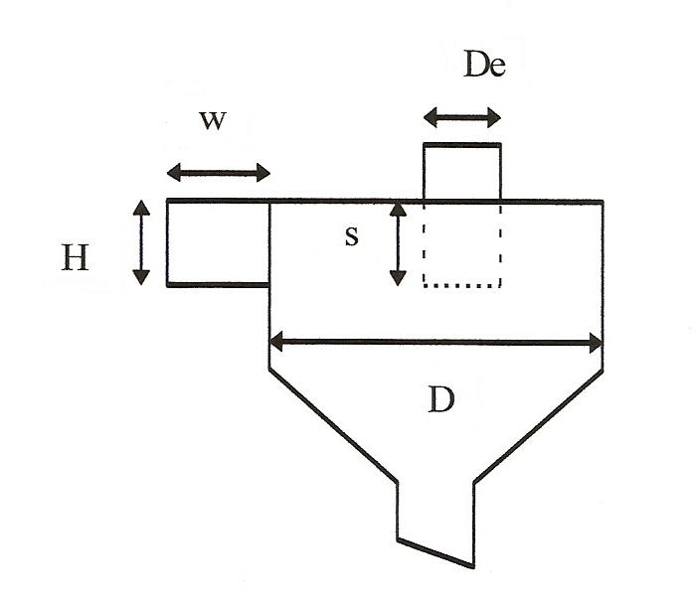
Table 1
Ratio Dimensions* | High Efficiency | Medium Efficiency | Low Efficiency
Height of inlet, H/D | ≤0.44 | >0.44 and <0.8 | ≥0.8
Width of inlet, w/D | ≤0.2 | >0.2 and <0.375 | ≥0.375
Diameter of gas exit, D_{e}/D | ≤0.4 | >0.4 and <0.75 | ≥0.75
Length of vortex finder, s/D | ≤0.5 | >0.5 and <0.875 | ≥0.875
*If one or more of the "ratio dimensions," as listed in Table 1, are in a different efficiency category (high, medium, low), then the lowest efficiency category shall be applied.

