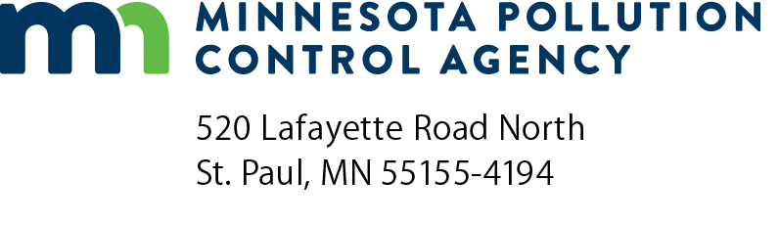 | 2023 Air emission inventory report Option B registration permittees  Air Emission Inventory Program  Doc Type: Air Emission Inventory - Criteria

Instructions: This form is due by April 1. Read each statement, fill in the appropriate fields, and sign the form. The form must be received via email or mail.

Submittal: Email completed reports to: optionbreport.pca@state.mn.us; or

Mail to: Rachel Olmanson, Minnesota Pollution Control Agency, 520 Lafayette Road North, St. Paul, Minnesota 55155.

Questions: Please contact Rachel Olmanson at rachel.olmanson@state.mn.us or 651-757-2473.
Facility information
Facility name:
Master AI ID number: |  |  |  |  |  | Facility/ Air permit number:
 | Site address:
 | City: |  |  |  | State: |  |  | Zip code:
Inventory contact (update the emission inventory contact information below)
Contact name: |  |  |  |  |  |  | Contact title:
 | Mailing address:
 | City: |  |  |  |  | State: |  |  |  |  | Zip code:
 | Phone: |  |  |  | Email:
Certification
- I certify that the facility listed above is eligible for the permit that it was issued, that the eligibility of my facility was determined under my direction or supervision, and that the information I used to determine eligibility is, to the best of my knowledge and belief, true and accurate.
- I certify that my facility purchased or used (as stated in the permit application)
gallons of Volatile Organic Compounds (VOC) -containing materials during the entire 2023 calendar year, that the quantity of VOC-containing material listed above was determined under my direction or supervision, and that the quantity of VOC-containing material reported above is, to the best of my knowledge and belief, true and accurate.
- I understand that the information provided in this report will be used by the Minnesota Pollution Control Agency to assess a fee which the facility will be required to pay.
Signature and title of company official:
Print name: |  | Title:
Signature: |  | Date (mm/dd/yyyy):

